|  |  |  |  |  |
| --- | --- | --- | --- | --- |
|  |  | | |  |
|  |  | | |  |
|  | Function Group Spec  Integrated Dash Camera Feature  <<Feature>> (Allocated) | | |  |
|  |  |
|  |  |
|  |  | | |  |
| Document Type | **Function Specification** | | |  |
| Template Version | **6.1a** | | |  |
| SysML Report Template Version | **M (03/09/2021)** | | |  |
| Document ID | **functionspec_sysmlreporttemplate** | | |  |
| Document Location |  | | |  |
| Document Owner | **Malik Eteer** | | |  |
| Document Revision | **FGS0** | | |  |
| Document Status | **Draft** | | |  |
| Date Issued | **2021/05/24** | | |  |
| Date Revised | **2021/05/24** | | |  |
| Document Classification | GIS1 Item Number: | **27.60/35** | |  |
| GIS2 Classification: | **Confidential** | |
|  | | | | |
|  | | | | |
| Document Approval | | | | |
| Name | Role | | Email Confirmation | Date |
|  |  | |  |  |
|  |  | |  |  |

Auto-Generated by MagicDraw

Printed Copies are Uncontrolled

# Disclaimer

**This document contains Ford Motor Company Confidential information. Disclosure of the information contained in any portion of this document is not permitted without the expressed, written consent of a duly authorized representative of Ford Motor Company, Dearborn, Michigan, U.S.A.**

**Copyright, Ó 2021 Ford Motor Company**

This document contains information developed and accumulated by and for FORD MOTOR COMPANY. As such, it is a proprietary document, which, if disseminated to unauthorized persons, would provide others with restricted information, data, or procedures not otherwise available, exposing the FORD MOTOR COMPANY to potential harm.

Employees and suppliers having custody of this specification or authorized to use it must be cognizant of its proprietary nature and ensure that the information herein is not made available to unauthorized persons.

FORD MOTOR COMPANY reserves the right to protect this work as an unpublished copyrighted work in the event of an inadvertent or deliberate unauthorized publication. FORD MOTOR COMPANY also reserves its rights under copyright laws to protect this work as a published work.

This document or portions thereof shall not be distributed outside FORD MOTOR COMPANY without prior written consent. Refer all questions concerning disclosure to the author(s) or to any duly authorized representative of Ford Motor Company.

# Contents

1.1.1 Decomposition of 4

Disclaimer 16

Contents 17

2 Introduction 19

2.1 Document Purpose 19

2.2 Document Scope 19

2.3 Document Audience 19

2.3.1 Stakeholder List 19

2.4 Document Organization 19

2.4.1 Document Context 19

2.4.2 Document Structure 19

2.5 Document Conventions 20

2.5.1 Requirements Templates 20

3 Function Group Description 21

4 Functional Architecture 22

4.1 Description 22

4.2 Function List 22

4.3 Signal List 22

5 Function Specifications 23

5.1  23

5.1.1 Function Overview 23

5.1.2 Function Scope 25

5.1.3 Function Interfaces 26

5.1.4 Function Modeling 28

5.1.5 Function Requirements 28

6 Open Concerns 32

7 Revision History 33

8 Appendix 34

8.1 Data Dictionary 34

8.1.1 Logical Signals 34

8.1.2 Logical Parameters 34

8.1.3 Encoding Types 34

8.2 Glossary 34

8.2.1 Definitions 34

8.2.2 Abbreviations 35

**List of Figures**

Figure 1 Activity diagram “” depicting black box behavior collaboration 22

Figure 2: Activity Diagram of “” calling “” 26

Figure 3: 28

**List of Tables**

Table 1: - Decomposition Table 5

Table 2: Functions described in this specification 19

Table 3: List of Logical Functions 22

Table 4: Ford internal Documents 25

Table 5: Ford internal Documents *(not specified in model)* 25

Table 6: External documents and publications 25

Table 7: External documents and publications *(not specified in model)* 25

Table 8: Open Concerns *(Not supported by MagicDraw report generation.)* 32

Table 9: Definitions used in this document 35

Table 10: Abbreviations used in this document 35

# Introduction

## Document Purpose

The Function (Group) Specification (FS) specifies an individual function / a group of functions.

To get more information about the concept of feature, function and component level abstraction refer to the [Ford RE Wiki](http://wiki.ford.com/display/RequirementsEngineering/Requirements+Engineering+for+SW+Enabled+Features).

## Document Scope

The following set of functions from the [Global Feature & Function List](https://www.vsemweb.ford.com:443/tc/launchapp?-attach=true&-s=226TCSession&-o=ZmZNi0JHx3NrTDAAAAAAAAAAAAA) is described in this specification.

|  |  |  |  |
| --- | --- | --- | --- |
| **Function ID** | **Function Name** | **Owner** | **Reference** |
|  | Integrated Dash Camera Feature  (Program(s): MY2024 CDX 747, CDX 746N) | Malik Eteer |  |

**Table 2: Functions described in this specification**

## Document Audience

The FS is authored by the owners of the individual functions. All Stakeholders, i.e., all people who have a valid interest in the functions and their behavior should read and, if possible, review the FS. It needs to be guaranteed, that all stakeholders have access to the currently valid version of the FS.

### Stakeholder List

For the latest list of the feature stakeholder and their roles & responsibilities refer to <Put VSEM Link here>.

|  |  |  |  |  |
| --- | --- | --- | --- | --- |
| **Name** | **CDSID** | **Contact Info** | **Role** | **Stakeholder Group** |

## Document Organization

### Document Context

Refer to the [Specification Structure page](http://wiki.ford.com/display/RequirementsEngineering/Specification+templates) in the [Ford RE Wiki](http://wiki.ford.com/display/RequirementsEngineering/Requirements+Engineering+for+SW+Enabled+Features) to understand how the FS relates to other Ford Requirements Documents and Specifications.

### Document Structure

The structure of this document is explained below:

**Section 1** – Introduction how to use this document including responsibilities and requisite documents. Explains the tterminology. Gives a clarification of the definitions, concepts and abbreviations used in the document.

**Section 2** – Function Group Description. Gives an overview and the purpose of the function group.

**Section 3** – Functional Architecture: Specifies the overall functional architecture of the function group

**Section 4** – Function Specifications: Specifies the logical functions of the function group in detail

**Section 5** – List of Open Concerns

**Section 6** Revision history including a list of new or modified requirements. The requirements in this document are tagged, and this section contains different types of tables listing all, new, or changed requirements by their title and page no.

**Section 7** – Appendix: Presenting additional data mainly in a tabular form, e.g., a data dictionary

## Document Conventions

### Requirements Templates

Refer to “[How to use the Specification Templates](http://wiki.ford.com/display/RequirementsEngineering/How+to+use+the+Specification+Templates?src=contextnavpagetreemode)” on how to use the specification templates and the VBA macros to create/edit the requirements in the specifications.

The VBA macro enable the import of the specification to VSEM (refer to ["How to import specifications into VSEM as separate requirements"](http://wiki.ford.com/pages/viewpage.action?pageId=104991616&src=contextnavpagetreemode)).

#### Identification of Requirements

The unique requirement ID given in the headline of any requirement follows the requirement throughout the development process. The requirement ID format follows a well-defined syntax.

All identifiers in a FS shall be composed of 4 parts:

* A leading prefix, which indicates the type of requirement (R=Requirement, UC=Use Case, SC=Scenario, …)
* A prefix, which indicates the abstraction level (F=Feature, FNC=Function, CMP = component).
* Followed by a name, indicating the scope, which the requirement belongs to (e.g. feature or function name )
* Ending with the actual requirement number

*Example:*

*R_FNC_LockArbitrator_00004* This is the fourth requirement on function level for the function Lock Arbitrator.

#### Requirements Attributes

The templates provided by *Specification_Macros.dotm* define a list of attributes for each requirement. This helps to classify the requirement. The attributes are explained at [RE Wiki - Requirements Attributes](http://wiki.ford.com/display/RequirementsEngineering/Requirements+Attributes?src=contextnavpagetreemode).

## References

### Ford Documents

List here all Ford internal documents, which are directly related to the feature.

No Ford documents specified in model.

### External Documents and Publications

The list of external documents could include books, reports and online sources.

No external documents and publications specified in model.

## Glossary

### Definitions

No terms specified.

### Abbreviations

No acronyms specified.

# Function Group Description

This Function Group consists of all functions allocated to 1652152323.jpg **Integrated Dash Camera Feature** <<Feature>> including all functions in their corresponding call trees.

Description of Integrated Dash Camera Feature:

The Integrated Dash Camera system allows users to capture vehicle data and video from a vehicle imaging surrounding system while driving and store the recorded data on removable on-board storage. IDC feature shall use the vehicle dash camera mounted behind the vehicle windshield glass without the obstruction from interior components (RVMD, Shade lines, brackets and other small trim pieces) to capture video and stored it the memory media available in the vehicle. Based on user command, the dash camera shall capture video of the exterior environment of the car at all times while driving as long as the portable available memory allows room to store files. The recorded files are available for the user as a play back on center display once the vehicle is in “Park” position. Drivers are able to configure the recording experience by Sync HMI. In addition, the Integrated Dash Camera system can allow user to select the vehicle data files to be added to the video files like GPS, vehicle speed and brake pedal pressed or not. The Date/Time and VIN are always recorded with the video files for traceability purpose.

# Functional Decomposition and Architecture

## Description

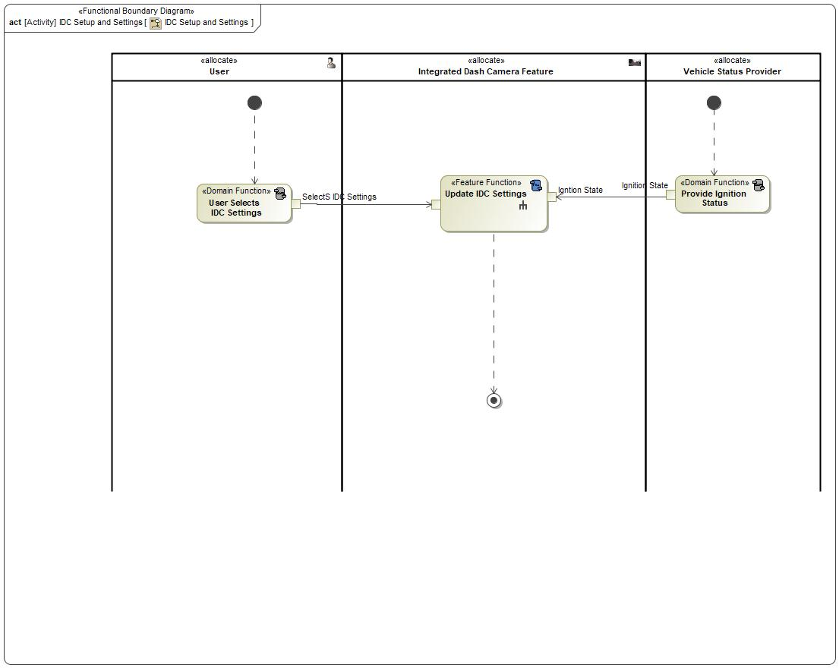

Figure Activity diagram “IDC Setup and Settings” depicting black box behavior collaboration

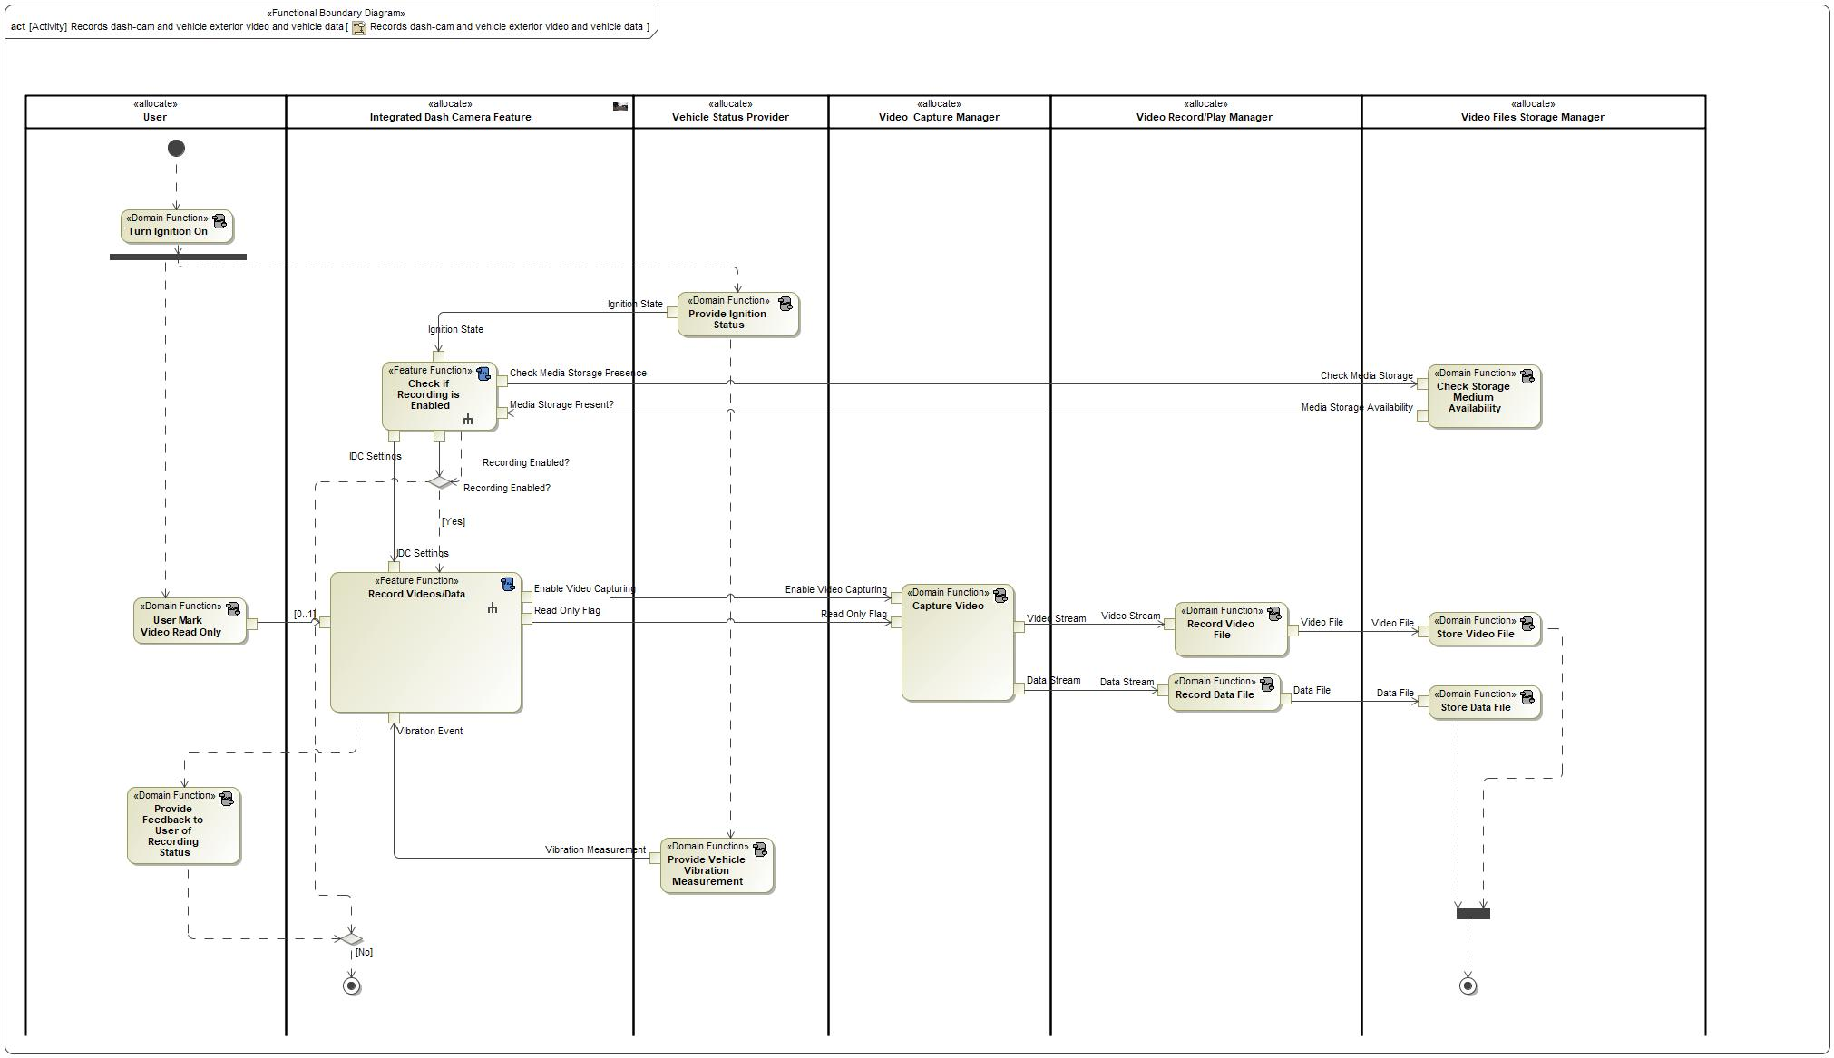

Figure Activity diagram “Records dash-cam and vehicle exterior video and vehicle data” depicting black box behavior collaboration

## Function List

|  |  |  |  |
| --- | --- | --- | --- |
| **Function ID** | **Function Name** | **Function Description** | **ASIL** |
|  | 1696244632.jpg Set Video Resolution <<Subsystem Function>> |  |  |
|  | 1212941180.jpg Check if File Storage is Available <<System Function>> |  |  |
|  | 1212941180.jpg Enable Recording <<System Function>> |  |  |
|  | 1212941180.jpg Process Event <<System Function>> |  |  |
|  | 1696244632.jpg Set GPS Logging <<Subsystem Function>> |  |  |
|  | 1212941180.jpg Check if IDC is Enabled in Settings <<System Function>> |  |  |
|  | 1696244632.jpg SelectVehicleSpeed <<Subsystem Function>> |  |  |
|  | 1696244632.jpg Retrieve Stored IDC Settings <<Subsystem Function>> |  |  |
|  | 1696244632.jpg Request Media Storage Status <<Subsystem Function>> |  |  |
|  | 1212941180.jpg Update Settings <<System Function>> |  |  |
|  | 1696244632.jpg Set G-SensorSetting <<Subsystem Function>> | When user selects Deny record button as shown in HMI3,camera stops recording |  |
|  | 1212941180.jpg Set Recording Status to Enable <<System Function>> |  |  |
|  | 1212941180.jpg Inform User No Media Storage is Available <<System Function>> |  |  |
|  | 1212941180.jpg Retrieve Settings <<System Function>> |  |  |
|  | 1212941180.jpg Set Recording Status to Disable <<System Function>> |  |  |
|  | 1696244632.jpg Set Loop Recording <<Subsystem Function>> |  |  |
|  | 1212941180.jpg Inform User Recording is Disabled <<System Function>> |  |  |
|  | 1696244632.jpg Use Stored Settings <<Subsystem Function>> |  |  |
|  | 1696244632.jpg Store IDC Settings <<Subsystem Function>> |  |  |
|  | 1212941180.jpg Mark As Read Only HMI <<System Function>> |  |  |
|  | 1212941180.jpg Display Settings <<System Function>> |  |  |
|  | 1696244632.jpg Use Default Settings <<Subsystem Function>> |  |  |
|  | 1212941180.jpg Issue A Read Only Flag <<System Function>> |  |  |
|  | 1212941180.jpg Save Settings <<System Function>> |  |  |
|  | 1696244632.jpg Display Settings <<Subsystem Function>> |  |  |
|  | 1696244632.jpg Set Recording Settings Status <<Subsystem Function>> |  |  |
|  | 1696244632.jpg Set Pedal Position <<Subsystem Function>> |  |  |
|  | 1696244632.jpg Receive Media Storage Status <<Subsystem Function>> |  |  |

Table 3: List of Logical Functions

## Signal List

Refer to the Data Dictionary - Logical Signals.

# Function Specifications

## Logical Function 1696244632.jpg Set Video Resolution

### Function Overview

#### Function Description

Function is allocated to:

* 510254531.jpg HMI Controller <<Logical>>

No description provided for this function.

#### Function Variants

*Not supported by MagicDraw report generation.*

|  |  |  |
| --- | --- | --- |
| Variant Name | Variant Description | Variant Condition (optional) |
| e.g. “High Content” |  | e.g. ExtLightTechnology = LED  OR  ExtLightTechnology = Xenon |

#### Input Requirements/Documents

|  |  |  |  |
| --- | --- | --- | --- |
| **Reference**  (Reference as listed in ch. ”References”) | **Section/Requirement** | **Description** | **Derived Requirement**  (optional – reference to requirement in ch. “Function Requirements”) |
| **Feature Requirements** | | | |
|  | <Example:  id + title of relevant Feature Docs> | <Example: “Requirements of Feature …”> | <Note: If you reference a requirement in this column, that requirement should have a trace link in its [“Source”/”Source Req.” attribute](http://wiki.ford.com/display/RequirementsEngineering/Requirements+Attributes) field pointing back to the input requirement (or to a requirement inside the input document) given in this table row> |
|  |  |  |  |
| **Ford Engineering Standards** | | | |
|  | <Example: some SDS (requirement)> |  |  |
|  |  |  |  |
| **Legal Regulations** | | | |
|  | Compliance with FMVSS111 | IDC shall adhere to rear view image regulation as described in FMVSS 111. |  |
|  | Compliance with FMVSS101 | IDC display shall adhere to user visibility described in FMVSS 101. |  |
|  |  |  |  |
| **Industry Standards** | | | |
|  | ISO 26262 | IDC shall be developed according to Ford's Implementation of Functional Safety (IDC qualified as QM/new changes will require new analysis). |  |
|  |  |  |  |
| **Other Sources** | | | |
|  |  |  |  |
|  |  |  |  |

Table 7: Input Requirements/Documents

#### Assumptions

No assumptions specified for this function.

### Function Scope

The 1696244632.jpg **– “Set Video Resolution”** function is called by the following functions:

* 1212941180.jpg – “Update Settings”

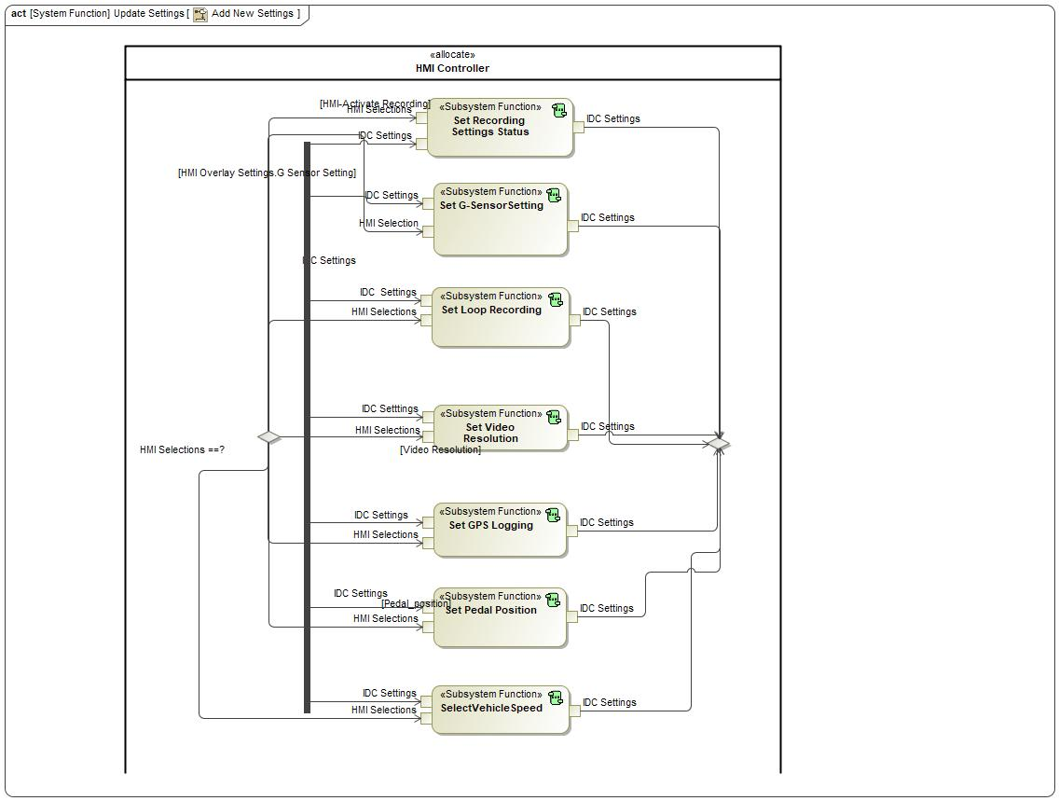

Figure : Activity Diagram of 1212941180.jpg “Add New Settings” calling 1696244632.jpg “Set Video Resolution”

### Function Interfaces

#### Logical Inputs

|  |  |
| --- | --- |
| **Signal Name** | **Description** |
| IDC Setttings  Type:  -1837289285.jpg IDC Settings Block |  |
| HMI Selections  Type:  -1837289285.jpg HMI Selections Block |  |

#### Logical Outputs

|  |  |
| --- | --- |
| **Signal Name** | **Description** |
| IDC Settings  Type:  33369235.jpg Video Settings |  |

#### Logical Parameters

*Not supported by MagicDraw report generation.*

|  |  |
| --- | --- |
| **Parameter Name** | **Description** |
| <(Mandatory) Word reference to the “Logical Parameters” name bookmark in the Data Dictionary> | <(Optional) Word reference to the “Logical Parameters” description bookmark in the Data Dictionary> |
|  |  |

### Function Modeling

#### Use Cases

*Not supported by MagicDraw report generation.*

#### State Charts

No state chart associated to specified function.

#### Activity Diagrams

No activity diagram associated to specified function.

#### Sequence Diagrams

No sequence diagram associated to specified function.

#### Decision Tables

### Function Requirements

#### Functional Requirements

##### Normal Operation

No Normal Operation Requirements specified.

##### Error Handling

No Error Handling Requirements specified.

#### Non-Functional Requirements

No Non-Functional Requirements specified.

#### Functional Safety Requirements

No Functional Safety Requirements specified.

#### Other Requirements

##### Design Requirements

No Design Requirements specified.

#### Uncategorized Requirements

FNC_SSR_0010 Set Recording Settings Status

HMI Controller shall allow user to make selections to alter IDC settings such as recording status, g-sensor, loop recording, video recording, GPS logging, pedal position, and vehicle speed.

|  |  |  |  |  |  |  |  |
| --- | --- | --- | --- | --- | --- | --- | --- |
| Requirement ID: FNC_SSR_0010 | | | | | | | |
| **Rationale** |  | | | | | | |
| **Acceptance Criteria** | To be written by Malik. | | | | | | |
| **Notes** |  | | | | | | |
| **Source** | To be written by Malik. | | | | | **Owner** | Malik Eteer |
| **Source Req.** | * 337127062.jpg F_HMI_001 Camera Settings * 337127062.jpg F_IF_0012 IDC Settings at Vehicle Wake-Up | | | | | **V&V Method** |  |
| **Type** |  | | | **Priority** | 1 | **Status** |  |
| [Req. Template](http://wiki.ford.com/display/RequirementsEngineering/Requirements+Attributes) Version | | 6.0 | End of Requirement | | | | |

## Logical Function 1212941180.jpg Check if File Storage is Available

### Function Overview

#### Function Description

Function is allocated to:

* 510254531.jpg IVI System <<Logical>>

No description provided for this function.

#### Function Variants

*Not supported by MagicDraw report generation.*

|  |  |  |
| --- | --- | --- |
| Variant Name | Variant Description | Variant Condition (optional) |
| e.g. “High Content” |  | e.g. ExtLightTechnology = LED  OR  ExtLightTechnology = Xenon |

#### Input Requirements/Documents

|  |  |  |  |
| --- | --- | --- | --- |
| **Reference**  (Reference as listed in ch. ”References”) | **Section/Requirement** | **Description** | **Derived Requirement**  (optional – reference to requirement in ch. “Function Requirements”) |
| **Feature Requirements** | | | |
|  | <Example:  id + title of relevant Feature Docs> | <Example: “Requirements of Feature …”> | <Note: If you reference a requirement in this column, that requirement should have a trace link in its [“Source”/”Source Req.” attribute](http://wiki.ford.com/display/RequirementsEngineering/Requirements+Attributes) field pointing back to the input requirement (or to a requirement inside the input document) given in this table row> |
|  |  |  |  |
| **Ford Engineering Standards** | | | |
|  | <Example: some SDS (requirement)> |  |  |
|  |  |  |  |
| **Legal Regulations** | | | |
|  | Compliance with FMVSS111 | IDC shall adhere to rear view image regulation as described in FMVSS 111. |  |
|  | Compliance with FMVSS101 | IDC display shall adhere to user visibility described in FMVSS 101. |  |
|  |  |  |  |
| **Industry Standards** | | | |
|  | ISO 26262 | IDC shall be developed according to Ford's Implementation of Functional Safety (IDC qualified as QM/new changes will require new analysis). |  |
|  |  |  |  |
| **Other Sources** | | | |
|  |  |  |  |
|  |  |  |  |

Table 7: Input Requirements/Documents

#### Assumptions

No assumptions specified for this function.

### Function Scope

The 1212941180.jpg **– “Check if File Storage is Available”** function is called by the following functions:

* -851712835.jpg – “Check if Recording is Enabled”

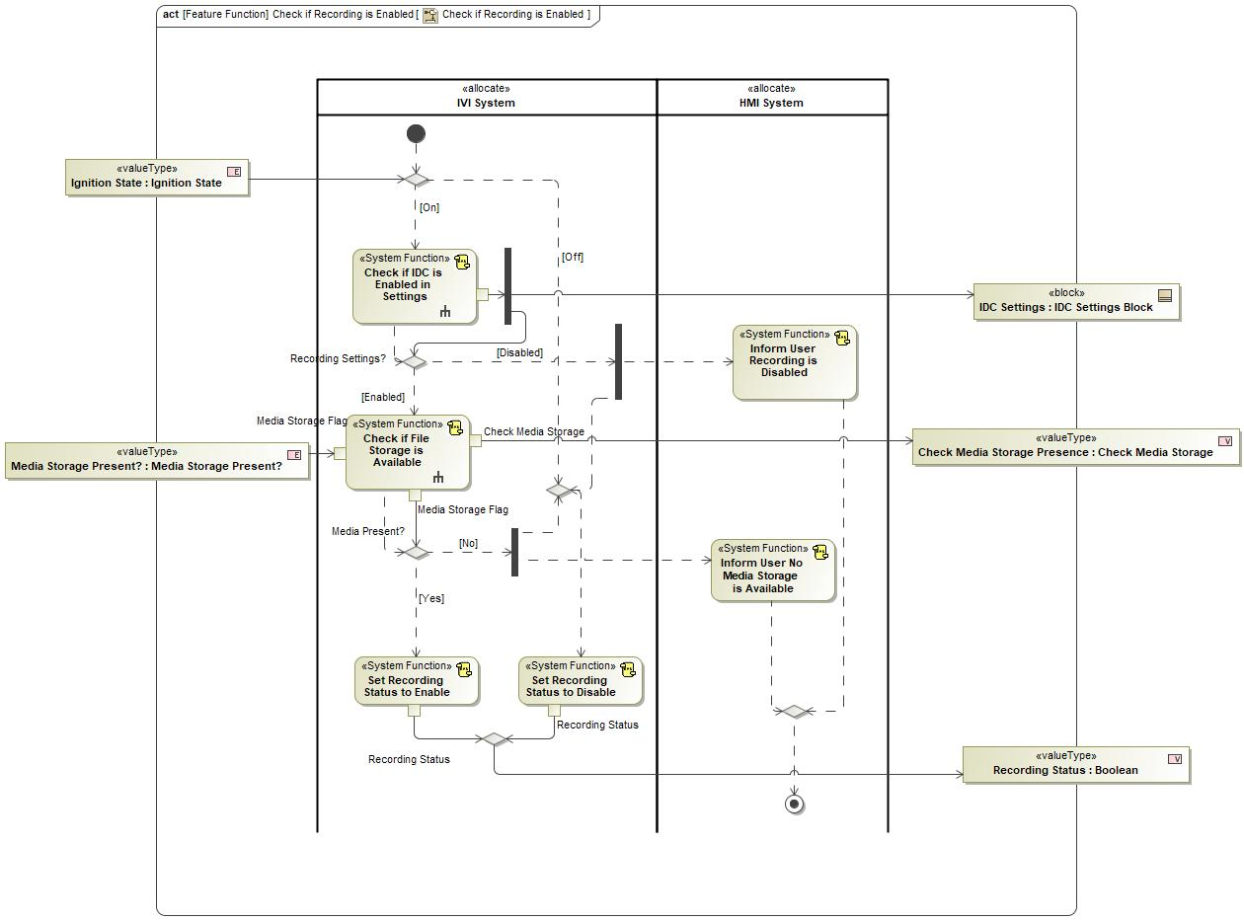

Figure : Activity Diagram of -851712835.jpg “Check if Recording is Enabled” calling 1212941180.jpg “Check if File Storage is Available”

### Function Interfaces

#### Logical Inputs

|  |  |
| --- | --- |
| **Signal Name** | **Description** |
| Media Storage Flag  Type:  1048467312.jpg Media Storage Present? | Signal Description:  Is a media storage device present to save files? yes or no? |

#### Logical Outputs

|  |  |
| --- | --- |
| **Signal Name** | **Description** |
| Media Storage Flag  Type:  1048467312.jpg Media Storage Present? | Signal Description:  Is a media storage device present to save files? yes or no? |
| Check Media Storage  Type:  33369235.jpg Check Media Storage |  |

#### Logical Parameters

*Not supported by MagicDraw report generation.*

|  |  |
| --- | --- |
| **Parameter Name** | **Description** |
| <(Mandatory) Word reference to the “Logical Parameters” name bookmark in the Data Dictionary> | <(Optional) Word reference to the “Logical Parameters” description bookmark in the Data Dictionary> |
|  |  |

### Function Modeling

#### Use Cases

*Not supported by MagicDraw report generation.*

#### State Charts

No state chart associated to specified function.

#### Activity Diagrams

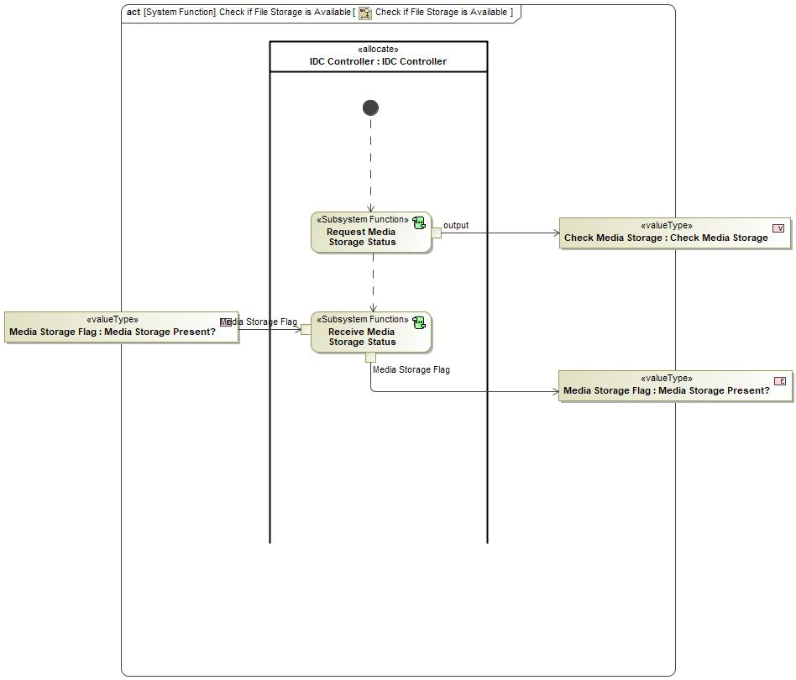

Figure 5: Check if File Storage is Available

#### Sequence Diagrams

No sequence diagram associated to specified function.

#### Decision Tables

### Function Requirements

#### Functional Requirements

##### Normal Operation

F_SR_001 Check if File Storage is Available

IVI system detects if file storage is available for video recordings.

|  |  |  |  |  |  |  |  |
| --- | --- | --- | --- | --- | --- | --- | --- |
| Requirement ID: F_SR_001 | | | | | | | |
| **Rationale** |  | | | | | | |
| **Acceptance Criteria** | To be written by Malik. | | | | | | |
| **Notes** |  | | | | | | |
| **Source** | To be written by Malik. | | | | | **Owner** | Malik Eteer |
| **Source Req.** | * 337127062.jpg F_IF_004 Inform the Driver of Recording Memory Status | | | | | **V&V Method** |  |
| **Type** |  | | | **Priority** | 1 | **Status** |  |
| [Req. Template](http://wiki.ford.com/display/RequirementsEngineering/Requirements+Attributes) Version | | 6.0 | End of Requirement | | | | |

##### Error Handling

No Error Handling Requirements specified.

#### Non-Functional Requirements

No Non-Functional Requirements specified.

#### Functional Safety Requirements

No Functional Safety Requirements specified.

#### Other Requirements

##### Design Requirements

No Design Requirements specified.

## Logical Function 1212941180.jpg Enable Recording

### Function Overview

#### Function Description

Function is allocated to:

* 510254531.jpg IVI System <<Logical>>

No description provided for this function.

#### Function Variants

*Not supported by MagicDraw report generation.*

|  |  |  |
| --- | --- | --- |
| Variant Name | Variant Description | Variant Condition (optional) |
| e.g. “High Content” |  | e.g. ExtLightTechnology = LED  OR  ExtLightTechnology = Xenon |

#### Input Requirements/Documents

|  |  |  |  |
| --- | --- | --- | --- |
| **Reference**  (Reference as listed in ch. ”References”) | **Section/Requirement** | **Description** | **Derived Requirement**  (optional – reference to requirement in ch. “Function Requirements”) |
| **Feature Requirements** | | | |
|  | <Example:  id + title of relevant Feature Docs> | <Example: “Requirements of Feature …”> | <Note: If you reference a requirement in this column, that requirement should have a trace link in its [“Source”/”Source Req.” attribute](http://wiki.ford.com/display/RequirementsEngineering/Requirements+Attributes) field pointing back to the input requirement (or to a requirement inside the input document) given in this table row> |
|  |  |  |  |
| **Ford Engineering Standards** | | | |
|  | <Example: some SDS (requirement)> |  |  |
|  |  |  |  |
| **Legal Regulations** | | | |
|  | Compliance with FMVSS111 | IDC shall adhere to rear view image regulation as described in FMVSS 111. |  |
|  | Compliance with FMVSS101 | IDC display shall adhere to user visibility described in FMVSS 101. |  |
|  |  |  |  |
| **Industry Standards** | | | |
|  | ISO 26262 | IDC shall be developed according to Ford's Implementation of Functional Safety (IDC qualified as QM/new changes will require new analysis). |  |
|  |  |  |  |
| **Other Sources** | | | |
|  |  |  |  |
|  |  |  |  |

Table 7: Input Requirements/Documents

#### Assumptions

No assumptions specified for this function.

### Function Scope

The 1212941180.jpg **– “Enable Recording”** function is called by the following functions:

* -851712835.jpg – “Record Videos/Data”

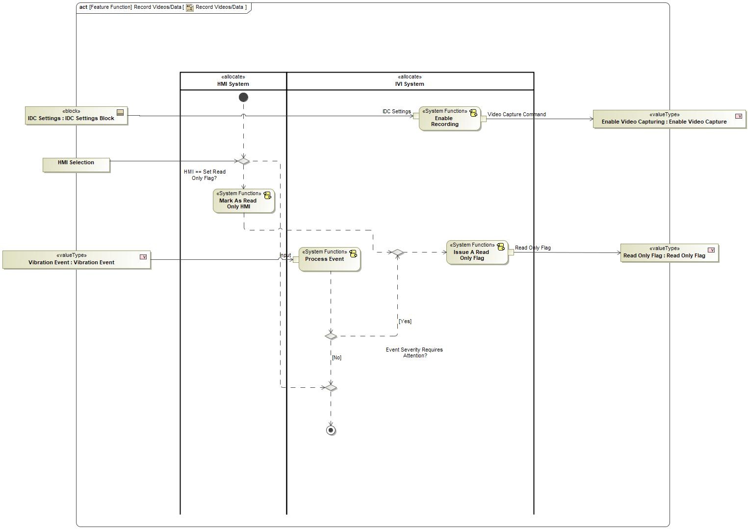

Figure : Activity Diagram of -851712835.jpg “Record Videos/Data” calling 1212941180.jpg “Enable Recording”

### Function Interfaces

#### Logical Inputs

|  |  |
| --- | --- |
| **Signal Name** | **Description** |
| IDC Settings  Type:  -1837289285.jpg IDC Settings Block |  |

#### Logical Outputs

|  |  |
| --- | --- |
| **Signal Name** | **Description** |
| Video Capture Command  Type:  33369235.jpg Enable Video Capture |  |

#### Logical Parameters

*Not supported by MagicDraw report generation.*

|  |  |
| --- | --- |
| **Parameter Name** | **Description** |
| <(Mandatory) Word reference to the “Logical Parameters” name bookmark in the Data Dictionary> | <(Optional) Word reference to the “Logical Parameters” description bookmark in the Data Dictionary> |
|  |  |

### Function Modeling

#### Use Cases

*Not supported by MagicDraw report generation.*

#### State Charts

No state chart associated to specified function.

#### Activity Diagrams

No activity diagram associated to specified function.

#### Sequence Diagrams

No sequence diagram associated to specified function.

#### Decision Tables

### Function Requirements

#### Functional Requirements

##### Normal Operation

F_SR_0014 IVI System Enable Recording

IVI system shall enable IDC to record.

|  |  |  |  |  |  |  |  |
| --- | --- | --- | --- | --- | --- | --- | --- |
| Requirement ID: F_SR_0014 | | | | | | | |
| **Rationale** |  | | | | | | |
| **Acceptance Criteria** | To be written by Malik. | | | | | | |
| **Notes** |  | | | | | | |
| **Source** | To be written by Malik. | | | | | **Owner** | Malik Eteer |
| **Source Req.** | * 337127062.jpg F_IF_0015 Enable Recording | | | | | **V&V Method** |  |
| **Type** |  | | | **Priority** | 1 | **Status** |  |
| [Req. Template](http://wiki.ford.com/display/RequirementsEngineering/Requirements+Attributes) Version | | 6.0 | End of Requirement | | | | |

##### Error Handling

No Error Handling Requirements specified.

#### Non-Functional Requirements

No Non-Functional Requirements specified.

#### Functional Safety Requirements

No Functional Safety Requirements specified.

#### Other Requirements

##### Design Requirements

No Design Requirements specified.

## Logical Function 1212941180.jpg Process Event

### Function Overview

#### Function Description

Function is allocated to:

* 510254531.jpg IVI System <<Logical>>

No description provided for this function.

#### Function Variants

*Not supported by MagicDraw report generation.*

|  |  |  |
| --- | --- | --- |
| Variant Name | Variant Description | Variant Condition (optional) |
| e.g. “High Content” |  | e.g. ExtLightTechnology = LED  OR  ExtLightTechnology = Xenon |

#### Input Requirements/Documents

|  |  |  |  |
| --- | --- | --- | --- |
| **Reference**  (Reference as listed in ch. ”References”) | **Section/Requirement** | **Description** | **Derived Requirement**  (optional – reference to requirement in ch. “Function Requirements”) |
| **Feature Requirements** | | | |
|  | <Example:  id + title of relevant Feature Docs> | <Example: “Requirements of Feature …”> | <Note: If you reference a requirement in this column, that requirement should have a trace link in its [“Source”/”Source Req.” attribute](http://wiki.ford.com/display/RequirementsEngineering/Requirements+Attributes) field pointing back to the input requirement (or to a requirement inside the input document) given in this table row> |
|  |  |  |  |
| **Ford Engineering Standards** | | | |
|  | <Example: some SDS (requirement)> |  |  |
|  |  |  |  |
| **Legal Regulations** | | | |
|  | Compliance with FMVSS111 | IDC shall adhere to rear view image regulation as described in FMVSS 111. |  |
|  | Compliance with FMVSS101 | IDC display shall adhere to user visibility described in FMVSS 101. |  |
|  |  |  |  |
| **Industry Standards** | | | |
|  | ISO 26262 | IDC shall be developed according to Ford's Implementation of Functional Safety (IDC qualified as QM/new changes will require new analysis). |  |
|  |  |  |  |
| **Other Sources** | | | |
|  |  |  |  |
|  |  |  |  |

Table 7: Input Requirements/Documents

#### Assumptions

No assumptions specified for this function.

### Function Scope

The 1212941180.jpg **– “Process Event”** function is called by the following functions:

* -851712835.jpg – “Record Videos/Data”



Figure : Activity Diagram of -851712835.jpg “Record Videos/Data” calling 1212941180.jpg “Process Event”

### Function Interfaces

#### Logical Inputs

|  |  |
| --- | --- |
| **Signal Name** | **Description** |
| input  Type:  33369235.jpg Vibration Event |  |

#### Logical Outputs

No Logical Outputs specified.

#### Logical Parameters

*Not supported by MagicDraw report generation.*

|  |  |
| --- | --- |
| **Parameter Name** | **Description** |
| <(Mandatory) Word reference to the “Logical Parameters” name bookmark in the Data Dictionary> | <(Optional) Word reference to the “Logical Parameters” description bookmark in the Data Dictionary> |
|  |  |

### Function Modeling

#### Use Cases

*Not supported by MagicDraw report generation.*

#### State Charts

No state chart associated to specified function.

#### Activity Diagrams

No activity diagram associated to specified function.

#### Sequence Diagrams

No sequence diagram associated to specified function.

#### Decision Tables

### Function Requirements

#### Functional Requirements

##### Normal Operation

F_SR_0018 Process Events During Recording

IVI system shall detect events during recording.

|  |  |  |  |  |  |  |  |
| --- | --- | --- | --- | --- | --- | --- | --- |
| Requirement ID: F_SR_0018 | | | | | | | |
| **Rationale** |  | | | | | | |
| **Acceptance Criteria** | To be written by Malik. | | | | | | |
| **Notes** |  | | | | | | |
| **Source** | To be written by Malik. | | | | | **Owner** | Malik Eteer |
| **Source Req.** | * 337127062.jpg F_IF_0013 Detect Events | | | | | **V&V Method** |  |
| **Type** |  | | | **Priority** | 1 | **Status** |  |
| [Req. Template](http://wiki.ford.com/display/RequirementsEngineering/Requirements+Attributes) Version | | 6.0 | End of Requirement | | | | |

##### Error Handling

No Error Handling Requirements specified.

#### Non-Functional Requirements

No Non-Functional Requirements specified.

#### Functional Safety Requirements

No Functional Safety Requirements specified.

#### Other Requirements

##### Design Requirements

No Design Requirements specified.

## Logical Function 1696244632.jpg Set GPS Logging

### Function Overview

#### Function Description

Function is allocated to:

* 510254531.jpg HMI Controller <<Logical>>

No description provided for this function.

#### Function Variants

*Not supported by MagicDraw report generation.*

|  |  |  |
| --- | --- | --- |
| Variant Name | Variant Description | Variant Condition (optional) |
| e.g. “High Content” |  | e.g. ExtLightTechnology = LED  OR  ExtLightTechnology = Xenon |

#### Input Requirements/Documents

|  |  |  |  |
| --- | --- | --- | --- |
| **Reference**  (Reference as listed in ch. ”References”) | **Section/Requirement** | **Description** | **Derived Requirement**  (optional – reference to requirement in ch. “Function Requirements”) |
| **Feature Requirements** | | | |
|  | <Example:  id + title of relevant Feature Docs> | <Example: “Requirements of Feature …”> | <Note: If you reference a requirement in this column, that requirement should have a trace link in its [“Source”/”Source Req.” attribute](http://wiki.ford.com/display/RequirementsEngineering/Requirements+Attributes) field pointing back to the input requirement (or to a requirement inside the input document) given in this table row> |
|  |  |  |  |
| **Ford Engineering Standards** | | | |
|  | <Example: some SDS (requirement)> |  |  |
|  |  |  |  |
| **Legal Regulations** | | | |
|  | Compliance with FMVSS111 | IDC shall adhere to rear view image regulation as described in FMVSS 111. |  |
|  | Compliance with FMVSS101 | IDC display shall adhere to user visibility described in FMVSS 101. |  |
|  |  |  |  |
| **Industry Standards** | | | |
|  | ISO 26262 | IDC shall be developed according to Ford's Implementation of Functional Safety (IDC qualified as QM/new changes will require new analysis). |  |
|  |  |  |  |
| **Other Sources** | | | |
|  |  |  |  |
|  |  |  |  |

Table 7: Input Requirements/Documents

#### Assumptions

No assumptions specified for this function.

### Function Scope

The 1696244632.jpg **– “Set GPS Logging”** function is called by the following functions:

* 1212941180.jpg – “Update Settings”



Figure : Activity Diagram of 1212941180.jpg “Add New Settings” calling 1696244632.jpg “Set GPS Logging”

### Function Interfaces

#### Logical Inputs

|  |  |
| --- | --- |
| **Signal Name** | **Description** |
| HMI Selections |  |
| IDC Settings  Type:  -1837289285.jpg IDC Settings Block |  |

#### Logical Outputs

|  |  |
| --- | --- |
| **Signal Name** | **Description** |
| IDC Settings  Type:  -1837289285.jpg IDC Settings Block |  |

#### Logical Parameters

*Not supported by MagicDraw report generation.*

|  |  |
| --- | --- |
| **Parameter Name** | **Description** |
| <(Mandatory) Word reference to the “Logical Parameters” name bookmark in the Data Dictionary> | <(Optional) Word reference to the “Logical Parameters” description bookmark in the Data Dictionary> |
|  |  |

### Function Modeling

#### Use Cases

*Not supported by MagicDraw report generation.*

#### State Charts

No state chart associated to specified function.

#### Activity Diagrams

No activity diagram associated to specified function.

#### Sequence Diagrams

No sequence diagram associated to specified function.

#### Decision Tables

### Function Requirements

#### Functional Requirements

##### Normal Operation

No Normal Operation Requirements specified.

##### Error Handling

No Error Handling Requirements specified.

#### Non-Functional Requirements

No Non-Functional Requirements specified.

#### Functional Safety Requirements

No Functional Safety Requirements specified.

#### Other Requirements

##### Design Requirements

No Design Requirements specified.

#### Uncategorized Requirements

FNC_SSR_0010 Set Recording Settings Status

HMI Controller shall allow user to make selections to alter IDC settings such as recording status, g-sensor, loop recording, video recording, GPS logging, pedal position, and vehicle speed.

|  |  |  |  |  |  |  |  |
| --- | --- | --- | --- | --- | --- | --- | --- |
| Requirement ID: FNC_SSR_0010 | | | | | | | |
| **Rationale** |  | | | | | | |
| **Acceptance Criteria** | To be written by Malik. | | | | | | |
| **Notes** |  | | | | | | |
| **Source** | To be written by Malik. | | | | | **Owner** | Malik Eteer |
| **Source Req.** | * 337127062.jpg F_HMI_001 Camera Settings * 337127062.jpg F_IF_0012 IDC Settings at Vehicle Wake-Up | | | | | **V&V Method** |  |
| **Type** |  | | | **Priority** | 1 | **Status** |  |
| [Req. Template](http://wiki.ford.com/display/RequirementsEngineering/Requirements+Attributes) Version | | 6.0 | End of Requirement | | | | |

## Logical Function 1212941180.jpg Check if IDC is Enabled in Settings

### Function Overview

#### Function Description

Function is allocated to:

* 510254531.jpg IVI System <<Logical>>

No description provided for this function.

#### Function Variants

*Not supported by MagicDraw report generation.*

|  |  |  |
| --- | --- | --- |
| Variant Name | Variant Description | Variant Condition (optional) |
| e.g. “High Content” |  | e.g. ExtLightTechnology = LED  OR  ExtLightTechnology = Xenon |

#### Input Requirements/Documents

|  |  |  |  |
| --- | --- | --- | --- |
| **Reference**  (Reference as listed in ch. ”References”) | **Section/Requirement** | **Description** | **Derived Requirement**  (optional – reference to requirement in ch. “Function Requirements”) |
| **Feature Requirements** | | | |
|  | <Example:  id + title of relevant Feature Docs> | <Example: “Requirements of Feature …”> | <Note: If you reference a requirement in this column, that requirement should have a trace link in its [“Source”/”Source Req.” attribute](http://wiki.ford.com/display/RequirementsEngineering/Requirements+Attributes) field pointing back to the input requirement (or to a requirement inside the input document) given in this table row> |
|  |  |  |  |
| **Ford Engineering Standards** | | | |
|  | <Example: some SDS (requirement)> |  |  |
|  |  |  |  |
| **Legal Regulations** | | | |
|  | Compliance with FMVSS111 | IDC shall adhere to rear view image regulation as described in FMVSS 111. |  |
|  | Compliance with FMVSS101 | IDC display shall adhere to user visibility described in FMVSS 101. |  |
|  |  |  |  |
| **Industry Standards** | | | |
|  | ISO 26262 | IDC shall be developed according to Ford's Implementation of Functional Safety (IDC qualified as QM/new changes will require new analysis). |  |
|  |  |  |  |
| **Other Sources** | | | |
|  |  |  |  |
|  |  |  |  |

Table 7: Input Requirements/Documents

#### Assumptions

No assumptions specified for this function.

### Function Scope

The 1212941180.jpg **– “Check if IDC is Enabled in Settings”** function is called by the following functions:

* -247077426.jpg – “Check if Recording is Enabled”



Figure : Activity Diagram of -247077426.jpg “Check if Recording is Enabled” calling 1212941180.jpg “Check if IDC is Enabled in Settings”

### Function Interfaces

#### Logical Inputs

No Logical Inputs specified.

#### Logical Outputs

|  |  |
| --- | --- |
| **Signal Name** | **Description** |
| Type:  -1837289285.jpg IDC Settings Block |  |

#### Logical Parameters

*Not supported by MagicDraw report generation.*

|  |  |
| --- | --- |
| **Parameter Name** | **Description** |
| <(Mandatory) Word reference to the “Logical Parameters” name bookmark in the Data Dictionary> | <(Optional) Word reference to the “Logical Parameters” description bookmark in the Data Dictionary> |
|  |  |

### Function Modeling

#### Use Cases

*Not supported by MagicDraw report generation.*

#### State Charts

No state chart associated to specified function.

#### Activity Diagrams

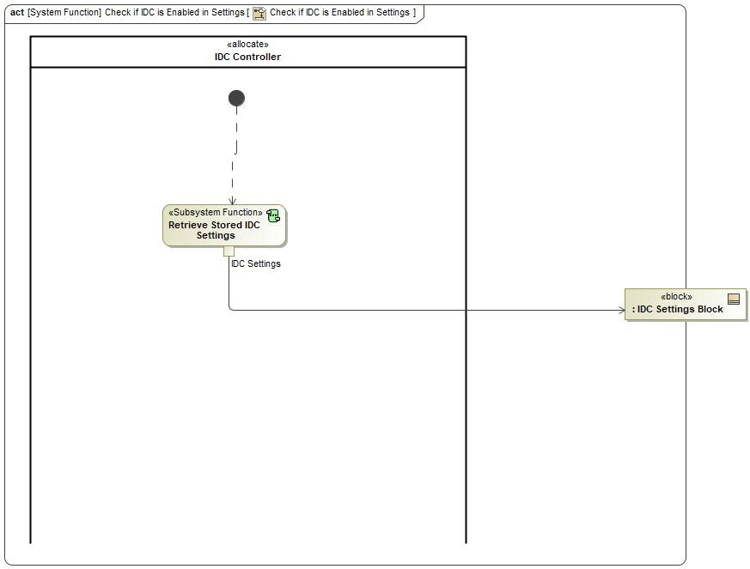

Figure 5: Check if IDC is Enabled in Settings

#### Sequence Diagrams

No sequence diagram associated to specified function.

#### Decision Tables

### Function Requirements

#### Functional Requirements

##### Normal Operation

F_SR_0017 Check if IDC is Enabled in Settings

IVI system detects if IDC is enabled in settings given the presence of required inputs.

|  |  |  |  |  |  |  |  |
| --- | --- | --- | --- | --- | --- | --- | --- |
| Requirement ID: F_SR_0017 | | | | | | | |
| **Rationale** |  | | | | | | |
| **Acceptance Criteria** | To be written by Malik. | | | | | | |
| **Notes** |  | | | | | | |
| **Source** | To be written by Malik. | | | | | **Owner** | Malik Eteer |
| **Source Req.** | * 337127062.jpg F_IF_001 Video and Vehicle Data Record on Command | | | | | **V&V Method** |  |
| **Type** |  | | | **Priority** | 1 | **Status** |  |
| [Req. Template](http://wiki.ford.com/display/RequirementsEngineering/Requirements+Attributes) Version | | 6.0 | End of Requirement | | | | |

##### Error Handling

No Error Handling Requirements specified.

#### Non-Functional Requirements

No Non-Functional Requirements specified.

#### Functional Safety Requirements

No Functional Safety Requirements specified.

#### Other Requirements

##### Design Requirements

No Design Requirements specified.

## Logical Function 1240868137.jpg SelectVehicleSpeed

### Function Overview

#### Function Description

Function is allocated to:

* 510254531.jpg HMI Controller <<Logical>>

No description provided for this function.

#### Function Variants

*Not supported by MagicDraw report generation.*

|  |  |  |
| --- | --- | --- |
| Variant Name | Variant Description | Variant Condition (optional) |
| e.g. “High Content” |  | e.g. ExtLightTechnology = LED  OR  ExtLightTechnology = Xenon |

#### Input Requirements/Documents

|  |  |  |  |
| --- | --- | --- | --- |
| **Reference**  (Reference as listed in ch. ”References”) | **Section/Requirement** | **Description** | **Derived Requirement**  (optional – reference to requirement in ch. “Function Requirements”) |
| **Feature Requirements** | | | |
|  | <Example:  id + title of relevant Feature Docs> | <Example: “Requirements of Feature …”> | <Note: If you reference a requirement in this column, that requirement should have a trace link in its [“Source”/”Source Req.” attribute](http://wiki.ford.com/display/RequirementsEngineering/Requirements+Attributes) field pointing back to the input requirement (or to a requirement inside the input document) given in this table row> |
|  |  |  |  |
| **Ford Engineering Standards** | | | |
|  | <Example: some SDS (requirement)> |  |  |
|  |  |  |  |
| **Legal Regulations** | | | |
|  | Compliance with FMVSS111 | IDC shall adhere to rear view image regulation as described in FMVSS 111. |  |
|  | Compliance with FMVSS101 | IDC display shall adhere to user visibility described in FMVSS 101. |  |
|  |  |  |  |
| **Industry Standards** | | | |
|  | ISO 26262 | IDC shall be developed according to Ford's Implementation of Functional Safety (IDC qualified as QM/new changes will require new analysis). |  |
|  |  |  |  |
| **Other Sources** | | | |
|  |  |  |  |
|  |  |  |  |

Table 7: Input Requirements/Documents

#### Assumptions

No assumptions specified for this function.

### Function Scope

The 1240868137.jpg **– “SelectVehicleSpeed”** function is called by the following functions:

* 1927245504.jpg – “Update Settings”



Figure : Activity Diagram of 1927245504.jpg “Add New Settings” calling 1240868137.jpg “SelectVehicleSpeed”

### Function Interfaces

#### Logical Inputs

|  |  |
| --- | --- |
| **Signal Name** | **Description** |
| IDC Settings  Type:  -1837289285.jpg IDC Settings Block |  |
| HMI Selections |  |

#### Logical Outputs

|  |  |
| --- | --- |
| **Signal Name** | **Description** |
| IDC Settings  Type:  -1837289285.jpg IDC Settings Block |  |

#### Logical Parameters

*Not supported by MagicDraw report generation.*

|  |  |
| --- | --- |
| **Parameter Name** | **Description** |
| <(Mandatory) Word reference to the “Logical Parameters” name bookmark in the Data Dictionary> | <(Optional) Word reference to the “Logical Parameters” description bookmark in the Data Dictionary> |
|  |  |

### Function Modeling

#### Use Cases

*Not supported by MagicDraw report generation.*

#### State Charts

No state chart associated to specified function.

#### Activity Diagrams

No activity diagram associated to specified function.

#### Sequence Diagrams

No sequence diagram associated to specified function.

#### Decision Tables

### Function Requirements

#### Functional Requirements

##### Normal Operation

No Normal Operation Requirements specified.

##### Error Handling

No Error Handling Requirements specified.

#### Non-Functional Requirements

No Non-Functional Requirements specified.

#### Functional Safety Requirements

No Functional Safety Requirements specified.

#### Other Requirements

##### Design Requirements

No Design Requirements specified.

#### Uncategorized Requirements

FNC_SSR_0010 Set Recording Settings Status

HMI Controller shall allow user to make selections to alter IDC settings such as recording status, g-sensor, loop recording, video recording, GPS logging, pedal position, and vehicle speed.

|  |  |  |  |  |  |  |  |
| --- | --- | --- | --- | --- | --- | --- | --- |
| Requirement ID: FNC_SSR_0010 | | | | | | | |
| **Rationale** |  | | | | | | |
| **Acceptance Criteria** | To be written by Malik. | | | | | | |
| **Notes** |  | | | | | | |
| **Source** | To be written by Malik. | | | | | **Owner** | Malik Eteer |
| **Source Req.** | * 337127062.jpg F_HMI_001 Camera Settings * 337127062.jpg F_IF_0012 IDC Settings at Vehicle Wake-Up | | | | | **V&V Method** |  |
| **Type** |  | | | **Priority** | 1 | **Status** |  |
| [Req. Template](http://wiki.ford.com/display/RequirementsEngineering/Requirements+Attributes) Version | | 6.0 | End of Requirement | | | | |

## Logical Function 1240868137.jpg Retrieve Stored IDC Settings

### Function Overview

#### Function Description

Function is allocated to:

* 510254531.jpg IDC Controller <<Logical>>

No description provided for this function.

#### Function Variants

*Not supported by MagicDraw report generation.*

|  |  |  |
| --- | --- | --- |
| Variant Name | Variant Description | Variant Condition (optional) |
| e.g. “High Content” |  | e.g. ExtLightTechnology = LED  OR  ExtLightTechnology = Xenon |

#### Input Requirements/Documents

|  |  |  |  |
| --- | --- | --- | --- |
| **Reference**  (Reference as listed in ch. ”References”) | **Section/Requirement** | **Description** | **Derived Requirement**  (optional – reference to requirement in ch. “Function Requirements”) |
| **Feature Requirements** | | | |
|  | <Example:  id + title of relevant Feature Docs> | <Example: “Requirements of Feature …”> | <Note: If you reference a requirement in this column, that requirement should have a trace link in its [“Source”/”Source Req.” attribute](http://wiki.ford.com/display/RequirementsEngineering/Requirements+Attributes) field pointing back to the input requirement (or to a requirement inside the input document) given in this table row> |
|  |  |  |  |
| **Ford Engineering Standards** | | | |
|  | <Example: some SDS (requirement)> |  |  |
|  |  |  |  |
| **Legal Regulations** | | | |
|  | Compliance with FMVSS111 | IDC shall adhere to rear view image regulation as described in FMVSS 111. |  |
|  | Compliance with FMVSS101 | IDC display shall adhere to user visibility described in FMVSS 101. |  |
|  |  |  |  |
| **Industry Standards** | | | |
|  | ISO 26262 | IDC shall be developed according to Ford's Implementation of Functional Safety (IDC qualified as QM/new changes will require new analysis). |  |
|  |  |  |  |
| **Other Sources** | | | |
|  |  |  |  |
|  |  |  |  |

Table 7: Input Requirements/Documents

#### Assumptions

No assumptions specified for this function.

### Function Scope

The 1240868137.jpg **– “Retrieve Stored IDC Settings”** function is called by the following functions:

* 1927245504.jpg – “Check if IDC is Enabled in Settings”
* 1927245504.jpg – “Retrieve Settings”



Figure : Activity Diagram of 1927245504.jpg “Check if IDC is Enabled in Settings” calling 1240868137.jpg “Retrieve Stored IDC Settings”

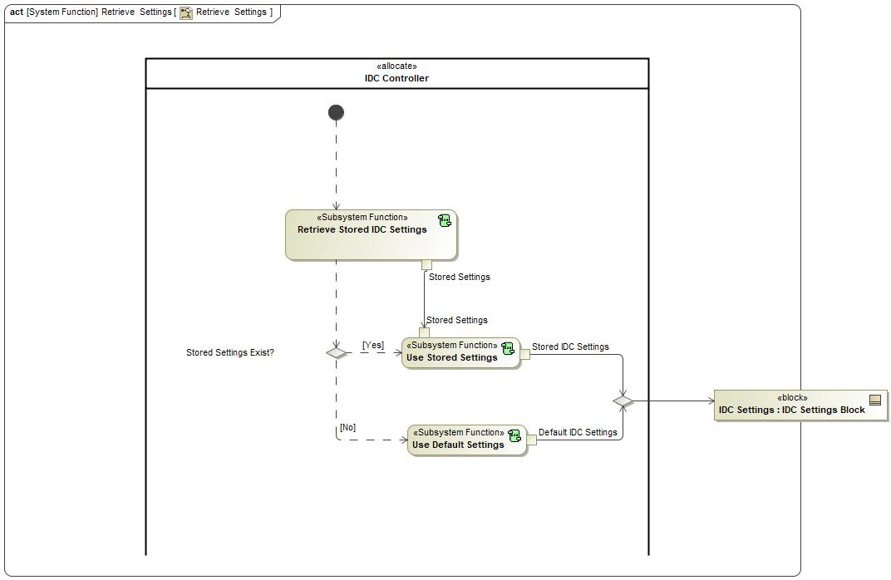

Figure : Activity Diagram of 1927245504.jpg “Retrieve Settings” calling 1240868137.jpg “Retrieve Stored IDC Settings”

### Function Interfaces

#### Logical Inputs

No Logical Inputs specified.

#### Logical Outputs

|  |  |
| --- | --- |
| **Signal Name** | **Description** |
| IDC Settings  Type:  -1837289285.jpg IDC Settings Block | Sent to:   * 1240868137.jpg Use Stored Settings |

#### Logical Parameters

*Not supported by MagicDraw report generation.*

|  |  |
| --- | --- |
| **Parameter Name** | **Description** |
| <(Mandatory) Word reference to the “Logical Parameters” name bookmark in the Data Dictionary> | <(Optional) Word reference to the “Logical Parameters” description bookmark in the Data Dictionary> |
|  |  |

### Function Modeling

#### Use Cases

*Not supported by MagicDraw report generation.*

#### State Charts

No state chart associated to specified function.

#### Activity Diagrams

No activity diagram associated to specified function.

#### Sequence Diagrams

No sequence diagram associated to specified function.

#### Decision Tables

### Function Requirements

#### Functional Requirements

##### Normal Operation

No Normal Operation Requirements specified.

##### Error Handling

No Error Handling Requirements specified.

#### Non-Functional Requirements

No Non-Functional Requirements specified.

#### Functional Safety Requirements

No Functional Safety Requirements specified.

#### Other Requirements

##### Design Requirements

No Design Requirements specified.

#### Uncategorized Requirements

FNC_SSR_002 Use Stored/Default Settings

When IDC starts, HMI Controller will attempt to retrieve stored settings from previous ignition cycle:

1. If found, use retrieved stored settings.

2. If not found, use default settings.

|  |  |  |  |  |  |  |  |
| --- | --- | --- | --- | --- | --- | --- | --- |
| Requirement ID: FNC_SSR_002 | | | | | | | |
| **Rationale** |  | | | | | | |
| **Acceptance Criteria** | To be written by Malik. | | | | | | |
| **Notes** |  | | | | | | |
| **Source** | To be written by Malik. | | | | | **Owner** | Malik Eteer |
| **Source Req.** | * 337127062.jpg F_HMI_001 Camera Settings * 337127062.jpg F_IF_0012 IDC Settings at Vehicle Wake-Up | | | | | **V&V Method** |  |
| **Type** |  | | | **Priority** | 1 | **Status** |  |
| [Req. Template](http://wiki.ford.com/display/RequirementsEngineering/Requirements+Attributes) Version | | 6.0 | End of Requirement | | | | |

## Logical Function 1240868137.jpg Request Media Storage Status

### Function Overview

#### Function Description

Function is allocated to:

* 510254531.jpg IDC Controller <<Logical>>

No description provided for this function.

#### Function Variants

*Not supported by MagicDraw report generation.*

|  |  |  |
| --- | --- | --- |
| Variant Name | Variant Description | Variant Condition (optional) |
| e.g. “High Content” |  | e.g. ExtLightTechnology = LED  OR  ExtLightTechnology = Xenon |

#### Input Requirements/Documents

|  |  |  |  |
| --- | --- | --- | --- |
| **Reference**  (Reference as listed in ch. ”References”) | **Section/Requirement** | **Description** | **Derived Requirement**  (optional – reference to requirement in ch. “Function Requirements”) |
| **Feature Requirements** | | | |
|  | <Example:  id + title of relevant Feature Docs> | <Example: “Requirements of Feature …”> | <Note: If you reference a requirement in this column, that requirement should have a trace link in its [“Source”/”Source Req.” attribute](http://wiki.ford.com/display/RequirementsEngineering/Requirements+Attributes) field pointing back to the input requirement (or to a requirement inside the input document) given in this table row> |
|  |  |  |  |
| **Ford Engineering Standards** | | | |
|  | <Example: some SDS (requirement)> |  |  |
|  |  |  |  |
| **Legal Regulations** | | | |
|  | Compliance with FMVSS111 | IDC shall adhere to rear view image regulation as described in FMVSS 111. |  |
|  | Compliance with FMVSS101 | IDC display shall adhere to user visibility described in FMVSS 101. |  |
|  |  |  |  |
| **Industry Standards** | | | |
|  | ISO 26262 | IDC shall be developed according to Ford's Implementation of Functional Safety (IDC qualified as QM/new changes will require new analysis). |  |
|  |  |  |  |
| **Other Sources** | | | |
|  |  |  |  |
|  |  |  |  |

Table 7: Input Requirements/Documents

#### Assumptions

No assumptions specified for this function.

### Function Scope

The 1240868137.jpg **– “Request Media Storage Status”** function is called by the following functions:

* 1927245504.jpg – “Check if File Storage is Available”



Figure : Activity Diagram of 1927245504.jpg “Check if File Storage is Available” calling 1240868137.jpg “Request Media Storage Status”

### Function Interfaces

#### Logical Inputs

No Logical Inputs specified.

#### Logical Outputs

|  |  |
| --- | --- |
| **Signal Name** | **Description** |
| output  Type:  -231332391.jpg Check Media Storage |  |

#### Logical Parameters

*Not supported by MagicDraw report generation.*

|  |  |
| --- | --- |
| **Parameter Name** | **Description** |
| <(Mandatory) Word reference to the “Logical Parameters” name bookmark in the Data Dictionary> | <(Optional) Word reference to the “Logical Parameters” description bookmark in the Data Dictionary> |
|  |  |

### Function Modeling

#### Use Cases

*Not supported by MagicDraw report generation.*

#### State Charts

No state chart associated to specified function.

#### Activity Diagrams

No activity diagram associated to specified function.

#### Sequence Diagrams

No sequence diagram associated to specified function.

#### Decision Tables

### Function Requirements

#### Functional Requirements

##### Normal Operation

FNC_SSR_009 Request Media Storage Status

IDC Controller shall request the media storage status.

|  |  |  |  |  |  |  |  |
| --- | --- | --- | --- | --- | --- | --- | --- |
| Requirement ID: FNC_SSR_009 | | | | | | | |
| **Rationale** |  | | | | | | |
| **Acceptance Criteria** | To be written by Malik. | | | | | | |
| **Notes** |  | | | | | | |
| **Source** | To be written by Malik. | | | | | **Owner** | Malik Eteer |
| **Source Req.** | * 337127062.jpg F_IF_004 Inform the Driver of Recording Memory Status | | | | | **V&V Method** |  |
| **Type** |  | | | **Priority** | 1 | **Status** |  |
| [Req. Template](http://wiki.ford.com/display/RequirementsEngineering/Requirements+Attributes) Version | | 6.0 | End of Requirement | | | | |

##### Error Handling

No Error Handling Requirements specified.

#### Non-Functional Requirements

No Non-Functional Requirements specified.

#### Functional Safety Requirements

No Functional Safety Requirements specified.

#### Other Requirements

##### Design Requirements

No Design Requirements specified.

## Logical Function 1927245504.jpg Update Settings

### Function Overview

#### Function Description

Function is allocated to:

* 510254531.jpg HMI System <<Logical>>
* 510254531.jpg IVI System <<Logical>>

No description provided for this function.

#### Function Variants

*Not supported by MagicDraw report generation.*

|  |  |  |
| --- | --- | --- |
| Variant Name | Variant Description | Variant Condition (optional) |
| e.g. “High Content” |  | e.g. ExtLightTechnology = LED  OR  ExtLightTechnology = Xenon |

#### Input Requirements/Documents

|  |  |  |  |
| --- | --- | --- | --- |
| **Reference**  (Reference as listed in ch. ”References”) | **Section/Requirement** | **Description** | **Derived Requirement**  (optional – reference to requirement in ch. “Function Requirements”) |
| **Feature Requirements** | | | |
|  | <Example:  id + title of relevant Feature Docs> | <Example: “Requirements of Feature …”> | <Note: If you reference a requirement in this column, that requirement should have a trace link in its [“Source”/”Source Req.” attribute](http://wiki.ford.com/display/RequirementsEngineering/Requirements+Attributes) field pointing back to the input requirement (or to a requirement inside the input document) given in this table row> |
|  |  |  |  |
| **Ford Engineering Standards** | | | |
|  | <Example: some SDS (requirement)> |  |  |
|  |  |  |  |
| **Legal Regulations** | | | |
|  | Compliance with FMVSS111 | IDC shall adhere to rear view image regulation as described in FMVSS 111. |  |
|  | Compliance with FMVSS101 | IDC display shall adhere to user visibility described in FMVSS 101. |  |
|  |  |  |  |
| **Industry Standards** | | | |
|  | ISO 26262 | IDC shall be developed according to Ford's Implementation of Functional Safety (IDC qualified as QM/new changes will require new analysis). |  |
|  |  |  |  |
| **Other Sources** | | | |
|  |  |  |  |
|  |  |  |  |

Table 7: Input Requirements/Documents

#### Assumptions

No assumptions specified for this function.

### Function Scope

The 1927245504.jpg **– “Update Settings”** function is called by the following functions:

* -247077426.jpg – “Update IDC Settings”

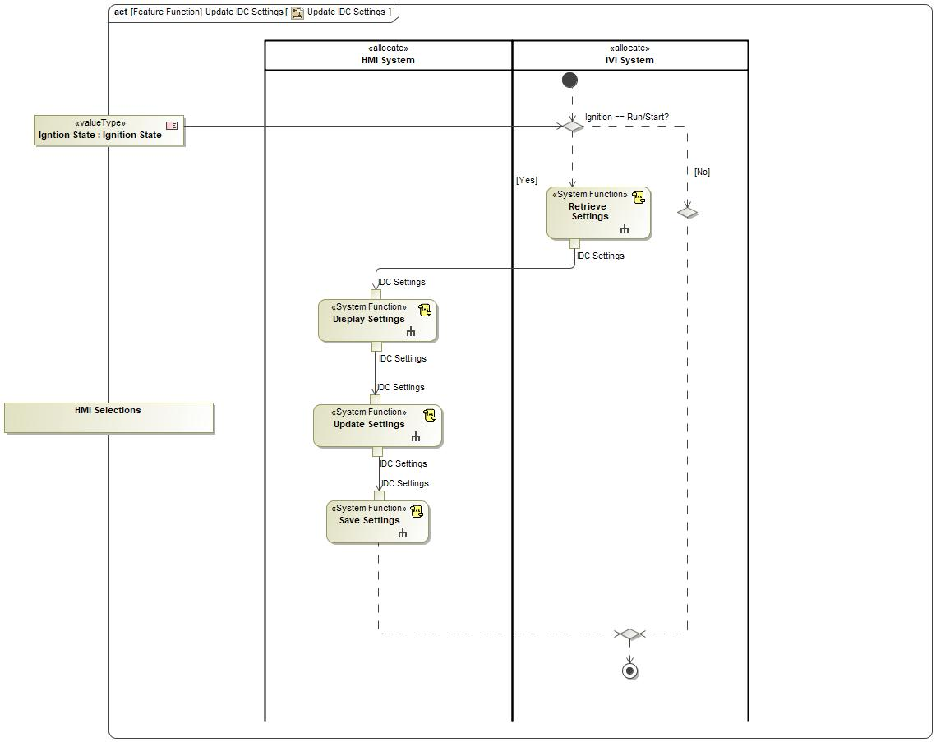

Figure : Activity Diagram of -247077426.jpg “Update IDC Settings” calling 1927245504.jpg “Update Settings”

### Function Interfaces

#### Logical Inputs

|  |  |
| --- | --- |
| **Signal Name** | **Description** |
| IDC Settings  Type:  -1837289285.jpg IDC Settings Block | Received from:   * 1927245504.jpg Display Settings |

#### Logical Outputs

|  |  |
| --- | --- |
| **Signal Name** | **Description** |
| IDC Settings  Type:  -1837289285.jpg IDC Settings Block | Sent to:   * 1927245504.jpg Save Settings |

#### Logical Parameters

*Not supported by MagicDraw report generation.*

|  |  |
| --- | --- |
| **Parameter Name** | **Description** |
| <(Mandatory) Word reference to the “Logical Parameters” name bookmark in the Data Dictionary> | <(Optional) Word reference to the “Logical Parameters” description bookmark in the Data Dictionary> |
|  |  |

### Function Modeling

#### Use Cases

*Not supported by MagicDraw report generation.*

#### State Charts

No state chart associated to specified function.

#### Activity Diagrams



Figure 5: Add New Settings

#### Sequence Diagrams

No sequence diagram associated to specified function.

#### Decision Tables

### Function Requirements

#### Functional Requirements

##### Normal Operation

No Normal Operation Requirements specified.

##### Error Handling

No Error Handling Requirements specified.

#### Non-Functional Requirements

No Non-Functional Requirements specified.

#### Functional Safety Requirements

No Functional Safety Requirements specified.

#### Other Requirements

##### Design Requirements

No Design Requirements specified.

#### Uncategorized Requirements

F_SR_0016 HMI Update Settings Selection

HMI system shall provide an HMI selection to update the display settings for the video recording.

|  |  |  |  |  |  |  |  |
| --- | --- | --- | --- | --- | --- | --- | --- |
| Requirement ID: F_SR_0016 | | | | | | | |
| **Rationale** |  | | | | | | |
| **Acceptance Criteria** | To be written by Malik. | | | | | | |
| **Notes** |  | | | | | | |
| **Source** | To be written by Malik. | | | | | **Owner** | Malik Eteer |
| **Source Req.** | * 337127062.jpg F_HMI_001 Camera Settings * 337127062.jpg F_HMI_008 Vehicle Data Settings * 337127062.jpg F_IF_007 Set Vehicle Data Recording Settings | | | | | **V&V Method** |  |
| **Type** |  | | | **Priority** | 1 | **Status** |  |
| [Req. Template](http://wiki.ford.com/display/RequirementsEngineering/Requirements+Attributes) Version | | 6.0 | End of Requirement | | | | |

## Logical Function 1240868137.jpg Set G-SensorSetting

### Function Overview

#### Function Description

Function is allocated to:

* 510254531.jpg HMI Controller <<Logical>>

When user selects Deny record button as shown in HMI3,camera stops recording

#### Function Variants

*Not supported by MagicDraw report generation.*

|  |  |  |
| --- | --- | --- |
| Variant Name | Variant Description | Variant Condition (optional) |
| e.g. “High Content” |  | e.g. ExtLightTechnology = LED  OR  ExtLightTechnology = Xenon |

#### Input Requirements/Documents

|  |  |  |  |
| --- | --- | --- | --- |
| **Reference**  (Reference as listed in ch. ”References”) | **Section/Requirement** | **Description** | **Derived Requirement**  (optional – reference to requirement in ch. “Function Requirements”) |
| **Feature Requirements** | | | |
|  | <Example:  id + title of relevant Feature Docs> | <Example: “Requirements of Feature …”> | <Note: If you reference a requirement in this column, that requirement should have a trace link in its [“Source”/”Source Req.” attribute](http://wiki.ford.com/display/RequirementsEngineering/Requirements+Attributes) field pointing back to the input requirement (or to a requirement inside the input document) given in this table row> |
|  |  |  |  |
| **Ford Engineering Standards** | | | |
|  | <Example: some SDS (requirement)> |  |  |
|  |  |  |  |
| **Legal Regulations** | | | |
|  | Compliance with FMVSS111 | IDC shall adhere to rear view image regulation as described in FMVSS 111. |  |
|  | Compliance with FMVSS101 | IDC display shall adhere to user visibility described in FMVSS 101. |  |
|  |  |  |  |
| **Industry Standards** | | | |
|  | ISO 26262 | IDC shall be developed according to Ford's Implementation of Functional Safety (IDC qualified as QM/new changes will require new analysis). |  |
|  |  |  |  |
| **Other Sources** | | | |
|  |  |  |  |
|  |  |  |  |

Table 7: Input Requirements/Documents

#### Assumptions

No assumptions specified for this function.

### Function Scope

The 1240868137.jpg **– “Set G-SensorSetting”** function is called by the following functions:

* 1927245504.jpg – “Update Settings”



Figure : Activity Diagram of 1927245504.jpg “Add New Settings” calling 1240868137.jpg “Set G-SensorSetting”

### Function Interfaces

#### Logical Inputs

|  |  |
| --- | --- |
| **Signal Name** | **Description** |
| HMI Selection |  |
| IDC Settings  Type:  -1837289285.jpg IDC Settings Block |  |

#### Logical Outputs

|  |  |
| --- | --- |
| **Signal Name** | **Description** |
| Video Settings  Type:  -1837289285.jpg IDC Settings Block |  |

#### Logical Parameters

*Not supported by MagicDraw report generation.*

|  |  |
| --- | --- |
| **Parameter Name** | **Description** |
| <(Mandatory) Word reference to the “Logical Parameters” name bookmark in the Data Dictionary> | <(Optional) Word reference to the “Logical Parameters” description bookmark in the Data Dictionary> |
|  |  |

### Function Modeling

#### Use Cases

*Not supported by MagicDraw report generation.*

#### State Charts

No state chart associated to specified function.

#### Activity Diagrams

No activity diagram associated to specified function.

#### Sequence Diagrams

No sequence diagram associated to specified function.

#### Decision Tables

### Function Requirements

#### Functional Requirements

##### Normal Operation

No Normal Operation Requirements specified.

##### Error Handling

No Error Handling Requirements specified.

#### Non-Functional Requirements

No Non-Functional Requirements specified.

#### Functional Safety Requirements

No Functional Safety Requirements specified.

#### Other Requirements

##### Design Requirements

No Design Requirements specified.

#### Uncategorized Requirements

FNC_SSR_0010 Set Recording Settings Status

HMI Controller shall allow user to make selections to alter IDC settings such as recording status, g-sensor, loop recording, video recording, GPS logging, pedal position, and vehicle speed.

|  |  |  |  |  |  |  |  |
| --- | --- | --- | --- | --- | --- | --- | --- |
| Requirement ID: FNC_SSR_0010 | | | | | | | |
| **Rationale** |  | | | | | | |
| **Acceptance Criteria** | To be written by Malik. | | | | | | |
| **Notes** |  | | | | | | |
| **Source** | To be written by Malik. | | | | | **Owner** | Malik Eteer |
| **Source Req.** | * 337127062.jpg F_HMI_001 Camera Settings * 337127062.jpg F_IF_0012 IDC Settings at Vehicle Wake-Up | | | | | **V&V Method** |  |
| **Type** |  | | | **Priority** | 1 | **Status** |  |
| [Req. Template](http://wiki.ford.com/display/RequirementsEngineering/Requirements+Attributes) Version | | 6.0 | End of Requirement | | | | |

## Logical Function 1927245504.jpg Set Recording Status to Enable

### Function Overview

#### Function Description

Function is allocated to:

* 510254531.jpg IVI System <<Logical>>

No description provided for this function.

#### Function Variants

*Not supported by MagicDraw report generation.*

|  |  |  |
| --- | --- | --- |
| Variant Name | Variant Description | Variant Condition (optional) |
| e.g. “High Content” |  | e.g. ExtLightTechnology = LED  OR  ExtLightTechnology = Xenon |

#### Input Requirements/Documents

|  |  |  |  |
| --- | --- | --- | --- |
| **Reference**  (Reference as listed in ch. ”References”) | **Section/Requirement** | **Description** | **Derived Requirement**  (optional – reference to requirement in ch. “Function Requirements”) |
| **Feature Requirements** | | | |
|  | <Example:  id + title of relevant Feature Docs> | <Example: “Requirements of Feature …”> | <Note: If you reference a requirement in this column, that requirement should have a trace link in its [“Source”/”Source Req.” attribute](http://wiki.ford.com/display/RequirementsEngineering/Requirements+Attributes) field pointing back to the input requirement (or to a requirement inside the input document) given in this table row> |
|  |  |  |  |
| **Ford Engineering Standards** | | | |
|  | <Example: some SDS (requirement)> |  |  |
|  |  |  |  |
| **Legal Regulations** | | | |
|  | Compliance with FMVSS111 | IDC shall adhere to rear view image regulation as described in FMVSS 111. |  |
|  | Compliance with FMVSS101 | IDC display shall adhere to user visibility described in FMVSS 101. |  |
|  |  |  |  |
| **Industry Standards** | | | |
|  | ISO 26262 | IDC shall be developed according to Ford's Implementation of Functional Safety (IDC qualified as QM/new changes will require new analysis). |  |
|  |  |  |  |
| **Other Sources** | | | |
|  |  |  |  |
|  |  |  |  |

Table 7: Input Requirements/Documents

#### Assumptions

No assumptions specified for this function.

### Function Scope

The 1927245504.jpg **– “Set Recording Status to Enable”** function is called by the following functions:

* -247077426.jpg – “Check if Recording is Enabled”



Figure : Activity Diagram of -247077426.jpg “Check if Recording is Enabled” calling 1927245504.jpg “Set Recording Status to Enable”

### Function Interfaces

#### Logical Inputs

No Logical Inputs specified.

#### Logical Outputs

|  |  |
| --- | --- |
| **Signal Name** | **Description** |
| Recording Status  Type:  -231332391.jpg Boolean |  |

#### Logical Parameters

*Not supported by MagicDraw report generation.*

|  |  |
| --- | --- |
| **Parameter Name** | **Description** |
| <(Mandatory) Word reference to the “Logical Parameters” name bookmark in the Data Dictionary> | <(Optional) Word reference to the “Logical Parameters” description bookmark in the Data Dictionary> |
|  |  |

### Function Modeling

#### Use Cases

*Not supported by MagicDraw report generation.*

#### State Charts

No state chart associated to specified function.

#### Activity Diagrams

No activity diagram associated to specified function.

#### Sequence Diagrams

No sequence diagram associated to specified function.

#### Decision Tables

### Function Requirements

#### Functional Requirements

##### Normal Operation

F_SR_0015 Set Recording Status to Enable or Disable

IVI system shall enable or disable IDC to record.

|  |  |  |  |  |  |  |  |
| --- | --- | --- | --- | --- | --- | --- | --- |
| Requirement ID: F_SR_0015 | | | | | | | |
| **Rationale** |  | | | | | | |
| **Acceptance Criteria** | To be written by Malik. | | | | | | |
| **Notes** |  | | | | | | |
| **Source** | To be written by Malik. | | | | | **Owner** | Malik Eteer |
| **Source Req.** | * 337127062.jpg F_IF_004 Inform the Driver of Recording Memory Status * 337127062.jpg F_IF_0011 Convey Recording Status Through HMI | | | | | **V&V Method** |  |
| **Type** |  | | | **Priority** | 1 | **Status** |  |
| [Req. Template](http://wiki.ford.com/display/RequirementsEngineering/Requirements+Attributes) Version | | 6.0 | End of Requirement | | | | |

##### Error Handling

No Error Handling Requirements specified.

#### Non-Functional Requirements

No Non-Functional Requirements specified.

#### Functional Safety Requirements

No Functional Safety Requirements specified.

#### Other Requirements

##### Design Requirements

No Design Requirements specified.

## Logical Function 1927245504.jpg Inform User No Media Storage is Available

### Function Overview

#### Function Description

Function is allocated to:

* 510254531.jpg HMI System <<Logical>>

No description provided for this function.

#### Function Variants

*Not supported by MagicDraw report generation.*

|  |  |  |
| --- | --- | --- |
| Variant Name | Variant Description | Variant Condition (optional) |
| e.g. “High Content” |  | e.g. ExtLightTechnology = LED  OR  ExtLightTechnology = Xenon |

#### Input Requirements/Documents

|  |  |  |  |
| --- | --- | --- | --- |
| **Reference**  (Reference as listed in ch. ”References”) | **Section/Requirement** | **Description** | **Derived Requirement**  (optional – reference to requirement in ch. “Function Requirements”) |
| **Feature Requirements** | | | |
|  | <Example:  id + title of relevant Feature Docs> | <Example: “Requirements of Feature …”> | <Note: If you reference a requirement in this column, that requirement should have a trace link in its [“Source”/”Source Req.” attribute](http://wiki.ford.com/display/RequirementsEngineering/Requirements+Attributes) field pointing back to the input requirement (or to a requirement inside the input document) given in this table row> |
|  |  |  |  |
| **Ford Engineering Standards** | | | |
|  | <Example: some SDS (requirement)> |  |  |
|  |  |  |  |
| **Legal Regulations** | | | |
|  | Compliance with FMVSS111 | IDC shall adhere to rear view image regulation as described in FMVSS 111. |  |
|  | Compliance with FMVSS101 | IDC display shall adhere to user visibility described in FMVSS 101. |  |
|  |  |  |  |
| **Industry Standards** | | | |
|  | ISO 26262 | IDC shall be developed according to Ford's Implementation of Functional Safety (IDC qualified as QM/new changes will require new analysis). |  |
|  |  |  |  |
| **Other Sources** | | | |
|  |  |  |  |
|  |  |  |  |

Table 7: Input Requirements/Documents

#### Assumptions

No assumptions specified for this function.

### Function Scope

The 1927245504.jpg **– “Inform User No Media Storage is Available”** function is called by the following functions:

* -247077426.jpg – “Check if Recording is Enabled”



Figure : Activity Diagram of -247077426.jpg “Check if Recording is Enabled” calling 1927245504.jpg “Inform User No Media Storage is Available”

### Function Interfaces

#### Logical Inputs

No Logical Inputs specified.

#### Logical Outputs

No Logical Outputs specified.

#### Logical Parameters

*Not supported by MagicDraw report generation.*

|  |  |
| --- | --- |
| **Parameter Name** | **Description** |
| <(Mandatory) Word reference to the “Logical Parameters” name bookmark in the Data Dictionary> | <(Optional) Word reference to the “Logical Parameters” description bookmark in the Data Dictionary> |
|  |  |

### Function Modeling

#### Use Cases

*Not supported by MagicDraw report generation.*

#### State Charts

No state chart associated to specified function.

#### Activity Diagrams

No activity diagram associated to specified function.

#### Sequence Diagrams

No sequence diagram associated to specified function.

#### Decision Tables

### Function Requirements

#### Functional Requirements

##### Normal Operation

No Normal Operation Requirements specified.

##### Error Handling

No Error Handling Requirements specified.

#### Non-Functional Requirements

No Non-Functional Requirements specified.

#### Functional Safety Requirements

No Functional Safety Requirements specified.

#### Other Requirements

##### Design Requirements

No Design Requirements specified.

#### Uncategorized Requirements

F_SR_008 Inform User No Media Storage Available

HMI system shall inform the user when no media storage is available.

|  |  |  |  |  |  |  |  |
| --- | --- | --- | --- | --- | --- | --- | --- |
| Requirement ID: F_SR_008 | | | | | | | |
| **Rationale** |  | | | | | | |
| **Acceptance Criteria** | To be written by Malik. | | | | | | |
| **Notes** |  | | | | | | |
| **Source** | To be written by Malik. | | | | | **Owner** | Malik Eteer |
| **Source Req.** | * 337127062.jpg F_IF_004 Inform the Driver of Recording Memory Status | | | | | **V&V Method** |  |
| **Type** |  | | | **Priority** | 1 | **Status** |  |
| [Req. Template](http://wiki.ford.com/display/RequirementsEngineering/Requirements+Attributes) Version | | 6.0 | End of Requirement | | | | |

## Logical Function 1927245504.jpg Retrieve Settings

### Function Overview

#### Function Description

Function is allocated to:

* 510254531.jpg IVI System <<Logical>>

No description provided for this function.

#### Function Variants

*Not supported by MagicDraw report generation.*

|  |  |  |
| --- | --- | --- |
| Variant Name | Variant Description | Variant Condition (optional) |
| e.g. “High Content” |  | e.g. ExtLightTechnology = LED  OR  ExtLightTechnology = Xenon |

#### Input Requirements/Documents

|  |  |  |  |
| --- | --- | --- | --- |
| **Reference**  (Reference as listed in ch. ”References”) | **Section/Requirement** | **Description** | **Derived Requirement**  (optional – reference to requirement in ch. “Function Requirements”) |
| **Feature Requirements** | | | |
|  | <Example:  id + title of relevant Feature Docs> | <Example: “Requirements of Feature …”> | <Note: If you reference a requirement in this column, that requirement should have a trace link in its [“Source”/”Source Req.” attribute](http://wiki.ford.com/display/RequirementsEngineering/Requirements+Attributes) field pointing back to the input requirement (or to a requirement inside the input document) given in this table row> |
|  |  |  |  |
| **Ford Engineering Standards** | | | |
|  | <Example: some SDS (requirement)> |  |  |
|  |  |  |  |
| **Legal Regulations** | | | |
|  | Compliance with FMVSS111 | IDC shall adhere to rear view image regulation as described in FMVSS 111. |  |
|  | Compliance with FMVSS101 | IDC display shall adhere to user visibility described in FMVSS 101. |  |
|  |  |  |  |
| **Industry Standards** | | | |
|  | ISO 26262 | IDC shall be developed according to Ford's Implementation of Functional Safety (IDC qualified as QM/new changes will require new analysis). |  |
|  |  |  |  |
| **Other Sources** | | | |
|  |  |  |  |
|  |  |  |  |

Table 7: Input Requirements/Documents

#### Assumptions

No assumptions specified for this function.

### Function Scope

The 1927245504.jpg **– “Retrieve Settings”** function is called by the following functions:

* -247077426.jpg – “Update IDC Settings”



Figure : Activity Diagram of -247077426.jpg “Update IDC Settings” calling 1927245504.jpg “Retrieve Settings”

### Function Interfaces

#### Logical Inputs

No Logical Inputs specified.

#### Logical Outputs

|  |  |
| --- | --- |
| **Signal Name** | **Description** |
| IDC Settings  Type:  -1837289285.jpg IDC Settings Block | Sent to:   * 1927245504.jpg Display Settings |

#### Logical Parameters

*Not supported by MagicDraw report generation.*

|  |  |
| --- | --- |
| **Parameter Name** | **Description** |
| <(Mandatory) Word reference to the “Logical Parameters” name bookmark in the Data Dictionary> | <(Optional) Word reference to the “Logical Parameters” description bookmark in the Data Dictionary> |
|  |  |

### Function Modeling

#### Use Cases

*Not supported by MagicDraw report generation.*

#### State Charts

No state chart associated to specified function.

#### Activity Diagrams



Figure 5: Retrieve Settings

#### Sequence Diagrams

No sequence diagram associated to specified function.

#### Decision Tables

### Function Requirements

#### Functional Requirements

##### Normal Operation

No Normal Operation Requirements specified.

##### Error Handling

No Error Handling Requirements specified.

#### Non-Functional Requirements

No Non-Functional Requirements specified.

#### Functional Safety Requirements

No Functional Safety Requirements specified.

#### Other Requirements

##### Design Requirements

No Design Requirements specified.

#### Uncategorized Requirements

F_SR_002 Retrieve Settings Upon Ignition

When starting IDC, the HMI system shall retrieve the settings saved in the previous ignition cycle. If no saved settings exist, the default factory settings will be retrieved.

|  |  |  |  |  |  |  |  |
| --- | --- | --- | --- | --- | --- | --- | --- |
| Requirement ID: F_SR_002 | | | | | | | |
| **Rationale** |  | | | | | | |
| **Acceptance Criteria** | To be written by Malik. | | | | | | |
| **Notes** |  | | | | | | |
| **Source** | To be written by Malik. | | | | | **Owner** | Malik Eteer |
| **Source Req.** | * 337127062.jpg F_IF_0012 IDC Settings at Vehicle Wake-Up | | | | | **V&V Method** |  |
| **Type** |  | | | **Priority** | 1 | **Status** |  |
| [Req. Template](http://wiki.ford.com/display/RequirementsEngineering/Requirements+Attributes) Version | | 6.0 | End of Requirement | | | | |

## Logical Function 1927245504.jpg Set Recording Status to Disable

### Function Overview

#### Function Description

Function is allocated to:

* 510254531.jpg IVI System <<Logical>>

No description provided for this function.

#### Function Variants

*Not supported by MagicDraw report generation.*

|  |  |  |
| --- | --- | --- |
| Variant Name | Variant Description | Variant Condition (optional) |
| e.g. “High Content” |  | e.g. ExtLightTechnology = LED  OR  ExtLightTechnology = Xenon |

#### Input Requirements/Documents

|  |  |  |  |
| --- | --- | --- | --- |
| **Reference**  (Reference as listed in ch. ”References”) | **Section/Requirement** | **Description** | **Derived Requirement**  (optional – reference to requirement in ch. “Function Requirements”) |
| **Feature Requirements** | | | |
|  | <Example:  id + title of relevant Feature Docs> | <Example: “Requirements of Feature …”> | <Note: If you reference a requirement in this column, that requirement should have a trace link in its [“Source”/”Source Req.” attribute](http://wiki.ford.com/display/RequirementsEngineering/Requirements+Attributes) field pointing back to the input requirement (or to a requirement inside the input document) given in this table row> |
|  |  |  |  |
| **Ford Engineering Standards** | | | |
|  | <Example: some SDS (requirement)> |  |  |
|  |  |  |  |
| **Legal Regulations** | | | |
|  | Compliance with FMVSS111 | IDC shall adhere to rear view image regulation as described in FMVSS 111. |  |
|  | Compliance with FMVSS101 | IDC display shall adhere to user visibility described in FMVSS 101. |  |
|  |  |  |  |
| **Industry Standards** | | | |
|  | ISO 26262 | IDC shall be developed according to Ford's Implementation of Functional Safety (IDC qualified as QM/new changes will require new analysis). |  |
|  |  |  |  |
| **Other Sources** | | | |
|  |  |  |  |
|  |  |  |  |

Table 7: Input Requirements/Documents

#### Assumptions

No assumptions specified for this function.

### Function Scope

The 1927245504.jpg **– “Set Recording Status to Disable”** function is called by the following functions:

* -247077426.jpg – “Check if Recording is Enabled”



Figure : Activity Diagram of -247077426.jpg “Check if Recording is Enabled” calling 1927245504.jpg “Set Recording Status to Disable”

### Function Interfaces

#### Logical Inputs

No Logical Inputs specified.

#### Logical Outputs

|  |  |
| --- | --- |
| **Signal Name** | **Description** |
| Set Recording Status to Enable(context EDC Controller)  Type:  -231332391.jpg Boolean |  |

#### Logical Parameters

*Not supported by MagicDraw report generation.*

|  |  |
| --- | --- |
| **Parameter Name** | **Description** |
| <(Mandatory) Word reference to the “Logical Parameters” name bookmark in the Data Dictionary> | <(Optional) Word reference to the “Logical Parameters” description bookmark in the Data Dictionary> |
|  |  |

### Function Modeling

#### Use Cases

*Not supported by MagicDraw report generation.*

#### State Charts

No state chart associated to specified function.

#### Activity Diagrams

No activity diagram associated to specified function.

#### Sequence Diagrams

No sequence diagram associated to specified function.

#### Decision Tables

### Function Requirements

#### Functional Requirements

##### Normal Operation

F_SR_0015 Set Recording Status to Enable or Disable

IVI system shall enable or disable IDC to record.

|  |  |  |  |  |  |  |  |
| --- | --- | --- | --- | --- | --- | --- | --- |
| Requirement ID: F_SR_0015 | | | | | | | |
| **Rationale** |  | | | | | | |
| **Acceptance Criteria** | To be written by Malik. | | | | | | |
| **Notes** |  | | | | | | |
| **Source** | To be written by Malik. | | | | | **Owner** | Malik Eteer |
| **Source Req.** | * 337127062.jpg F_IF_004 Inform the Driver of Recording Memory Status * 337127062.jpg F_IF_0011 Convey Recording Status Through HMI | | | | | **V&V Method** |  |
| **Type** |  | | | **Priority** | 1 | **Status** |  |
| [Req. Template](http://wiki.ford.com/display/RequirementsEngineering/Requirements+Attributes) Version | | 6.0 | End of Requirement | | | | |

##### Error Handling

No Error Handling Requirements specified.

#### Non-Functional Requirements

No Non-Functional Requirements specified.

#### Functional Safety Requirements

No Functional Safety Requirements specified.

#### Other Requirements

##### Design Requirements

No Design Requirements specified.

## Logical Function -152244866.jpg Set Loop Recording

### Function Overview

#### Function Description

Function is allocated to:

* 510254531.jpg HMI Controller <<Logical>>

No description provided for this function.

#### Function Variants

*Not supported by MagicDraw report generation.*

|  |  |  |
| --- | --- | --- |
| Variant Name | Variant Description | Variant Condition (optional) |
| e.g. “High Content” |  | e.g. ExtLightTechnology = LED  OR  ExtLightTechnology = Xenon |

#### Input Requirements/Documents

|  |  |  |  |
| --- | --- | --- | --- |
| **Reference**  (Reference as listed in ch. ”References”) | **Section/Requirement** | **Description** | **Derived Requirement**  (optional – reference to requirement in ch. “Function Requirements”) |
| **Feature Requirements** | | | |
|  | <Example:  id + title of relevant Feature Docs> | <Example: “Requirements of Feature …”> | <Note: If you reference a requirement in this column, that requirement should have a trace link in its [“Source”/”Source Req.” attribute](http://wiki.ford.com/display/RequirementsEngineering/Requirements+Attributes) field pointing back to the input requirement (or to a requirement inside the input document) given in this table row> |
|  |  |  |  |
| **Ford Engineering Standards** | | | |
|  | <Example: some SDS (requirement)> |  |  |
|  |  |  |  |
| **Legal Regulations** | | | |
|  | Compliance with FMVSS111 | IDC shall adhere to rear view image regulation as described in FMVSS 111. |  |
|  | Compliance with FMVSS101 | IDC display shall adhere to user visibility described in FMVSS 101. |  |
|  |  |  |  |
| **Industry Standards** | | | |
|  | ISO 26262 | IDC shall be developed according to Ford's Implementation of Functional Safety (IDC qualified as QM/new changes will require new analysis). |  |
|  |  |  |  |
| **Other Sources** | | | |
|  |  |  |  |
|  |  |  |  |

Table 7: Input Requirements/Documents

#### Assumptions

No assumptions specified for this function.

### Function Scope

The -152244866.jpg **– “Set Loop Recording”** function is called by the following functions:

* 1927245504.jpg – “Update Settings”



Figure : Activity Diagram of 1927245504.jpg “Add New Settings” calling -152244866.jpg “Set Loop Recording”

### Function Interfaces

#### Logical Inputs

|  |  |
| --- | --- |
| **Signal Name** | **Description** |
| HMI Selections |  |
| IDC Settings  Type:  -1837289285.jpg IDC Settings Block |  |

#### Logical Outputs

|  |  |
| --- | --- |
| **Signal Name** | **Description** |
| IDC Settings  Type:  368850836.jpg Video Settings |  |

#### Logical Parameters

*Not supported by MagicDraw report generation.*

|  |  |
| --- | --- |
| **Parameter Name** | **Description** |
| <(Mandatory) Word reference to the “Logical Parameters” name bookmark in the Data Dictionary> | <(Optional) Word reference to the “Logical Parameters” description bookmark in the Data Dictionary> |
|  |  |

### Function Modeling

#### Use Cases

*Not supported by MagicDraw report generation.*

#### State Charts

No state chart associated to specified function.

#### Activity Diagrams

No activity diagram associated to specified function.

#### Sequence Diagrams

No sequence diagram associated to specified function.

#### Decision Tables

### Function Requirements

#### Functional Requirements

##### Normal Operation

No Normal Operation Requirements specified.

##### Error Handling

No Error Handling Requirements specified.

#### Non-Functional Requirements

No Non-Functional Requirements specified.

#### Functional Safety Requirements

No Functional Safety Requirements specified.

#### Other Requirements

##### Design Requirements

No Design Requirements specified.

#### Uncategorized Requirements

FNC_SSR_0010 Set Recording Settings Status

HMI Controller shall allow user to make selections to alter IDC settings such as recording status, g-sensor, loop recording, video recording, GPS logging, pedal position, and vehicle speed.

|  |  |  |  |  |  |  |  |
| --- | --- | --- | --- | --- | --- | --- | --- |
| Requirement ID: FNC_SSR_0010 | | | | | | | |
| **Rationale** |  | | | | | | |
| **Acceptance Criteria** | To be written by Malik. | | | | | | |
| **Notes** |  | | | | | | |
| **Source** | To be written by Malik. | | | | | **Owner** | Malik Eteer |
| **Source Req.** | * 337127062.jpg F_HMI_001 Camera Settings * 337127062.jpg F_IF_0012 IDC Settings at Vehicle Wake-Up | | | | | **V&V Method** |  |
| **Type** |  | | | **Priority** | 1 | **Status** |  |
| [Req. Template](http://wiki.ford.com/display/RequirementsEngineering/Requirements+Attributes) Version | | 6.0 | End of Requirement | | | | |

## Logical Function -1718407727.jpg Inform User Recording is Disabled

### Function Overview

#### Function Description

Function is allocated to:

* 510254531.jpg HMI System <<Logical>>

No description provided for this function.

#### Function Variants

*Not supported by MagicDraw report generation.*

|  |  |  |
| --- | --- | --- |
| Variant Name | Variant Description | Variant Condition (optional) |
| e.g. “High Content” |  | e.g. ExtLightTechnology = LED  OR  ExtLightTechnology = Xenon |

#### Input Requirements/Documents

|  |  |  |  |
| --- | --- | --- | --- |
| **Reference**  (Reference as listed in ch. ”References”) | **Section/Requirement** | **Description** | **Derived Requirement**  (optional – reference to requirement in ch. “Function Requirements”) |
| **Feature Requirements** | | | |
|  | <Example:  id + title of relevant Feature Docs> | <Example: “Requirements of Feature …”> | <Note: If you reference a requirement in this column, that requirement should have a trace link in its [“Source”/”Source Req.” attribute](http://wiki.ford.com/display/RequirementsEngineering/Requirements+Attributes) field pointing back to the input requirement (or to a requirement inside the input document) given in this table row> |
|  |  |  |  |
| **Ford Engineering Standards** | | | |
|  | <Example: some SDS (requirement)> |  |  |
|  |  |  |  |
| **Legal Regulations** | | | |
|  | Compliance with FMVSS111 | IDC shall adhere to rear view image regulation as described in FMVSS 111. |  |
|  | Compliance with FMVSS101 | IDC display shall adhere to user visibility described in FMVSS 101. |  |
|  |  |  |  |
| **Industry Standards** | | | |
|  | ISO 26262 | IDC shall be developed according to Ford's Implementation of Functional Safety (IDC qualified as QM/new changes will require new analysis). |  |
|  |  |  |  |
| **Other Sources** | | | |
|  |  |  |  |
|  |  |  |  |

Table 7: Input Requirements/Documents

#### Assumptions

No assumptions specified for this function.

### Function Scope

The -1718407727.jpg **– “Inform User Recording is Disabled”** function is called by the following functions:

* -247077426.jpg – “Check if Recording is Enabled”



Figure : Activity Diagram of -247077426.jpg “Check if Recording is Enabled” calling -1718407727.jpg “Inform User Recording is Disabled”

### Function Interfaces

#### Logical Inputs

No Logical Inputs specified.

#### Logical Outputs

No Logical Outputs specified.

#### Logical Parameters

*Not supported by MagicDraw report generation.*

|  |  |
| --- | --- |
| **Parameter Name** | **Description** |
| <(Mandatory) Word reference to the “Logical Parameters” name bookmark in the Data Dictionary> | <(Optional) Word reference to the “Logical Parameters” description bookmark in the Data Dictionary> |
|  |  |

### Function Modeling

#### Use Cases

*Not supported by MagicDraw report generation.*

#### State Charts

No state chart associated to specified function.

#### Activity Diagrams

No activity diagram associated to specified function.

#### Sequence Diagrams

No sequence diagram associated to specified function.

#### Decision Tables

### Function Requirements

#### Functional Requirements

##### Normal Operation

No Normal Operation Requirements specified.

##### Error Handling

No Error Handling Requirements specified.

#### Non-Functional Requirements

No Non-Functional Requirements specified.

#### Functional Safety Requirements

No Functional Safety Requirements specified.

#### Other Requirements

##### Design Requirements

No Design Requirements specified.

#### Uncategorized Requirements

F_SR_0010 Inform User Recording is Disabled

HMI system shall inform the user when recording capabilities for IDC are disabled (i.e. no media storage available).

|  |  |  |  |  |  |  |  |
| --- | --- | --- | --- | --- | --- | --- | --- |
| Requirement ID: F_SR_0010 | | | | | | | |
| **Rationale** |  | | | | | | |
| **Acceptance Criteria** | To be written by Malik. | | | | | | |
| **Notes** |  | | | | | | |
| **Source** | To be written by Malik. | | | | | **Owner** | Malik Eteer |
| **Source Req.** | * 337127062.jpg F_IF_004 Inform the Driver of Recording Memory Status * 337127062.jpg F_IF_0011 Convey Recording Status Through HMI | | | | | **V&V Method** |  |
| **Type** |  | | | **Priority** | 1 | **Status** |  |
| [Req. Template](http://wiki.ford.com/display/RequirementsEngineering/Requirements+Attributes) Version | | 6.0 | End of Requirement | | | | |

## Logical Function 1240868137.jpg Use Stored Settings

### Function Overview

#### Function Description

Function is allocated to:

* 510254531.jpg HMI Actuator <<Logical>>
* 510254531.jpg IDC Controller <<Logical>>
* 510254531.jpg IVI System <<Logical>>

No description provided for this function.

#### Function Variants

*Not supported by MagicDraw report generation.*

|  |  |  |
| --- | --- | --- |
| Variant Name | Variant Description | Variant Condition (optional) |
| e.g. “High Content” |  | e.g. ExtLightTechnology = LED  OR  ExtLightTechnology = Xenon |

#### Input Requirements/Documents

|  |  |  |  |
| --- | --- | --- | --- |
| **Reference**  (Reference as listed in ch. ”References”) | **Section/Requirement** | **Description** | **Derived Requirement**  (optional – reference to requirement in ch. “Function Requirements”) |
| **Feature Requirements** | | | |
|  | <Example:  id + title of relevant Feature Docs> | <Example: “Requirements of Feature …”> | <Note: If you reference a requirement in this column, that requirement should have a trace link in its [“Source”/”Source Req.” attribute](http://wiki.ford.com/display/RequirementsEngineering/Requirements+Attributes) field pointing back to the input requirement (or to a requirement inside the input document) given in this table row> |
|  |  |  |  |
| **Ford Engineering Standards** | | | |
|  | <Example: some SDS (requirement)> |  |  |
|  |  |  |  |
| **Legal Regulations** | | | |
|  | Compliance with FMVSS111 | IDC shall adhere to rear view image regulation as described in FMVSS 111. |  |
|  | Compliance with FMVSS101 | IDC display shall adhere to user visibility described in FMVSS 101. |  |
|  |  |  |  |
| **Industry Standards** | | | |
|  | ISO 26262 | IDC shall be developed according to Ford's Implementation of Functional Safety (IDC qualified as QM/new changes will require new analysis). |  |
|  |  |  |  |
| **Other Sources** | | | |
|  |  |  |  |
|  |  |  |  |

Table 7: Input Requirements/Documents

#### Assumptions

No assumptions specified for this function.

### Function Scope

The 1240868137.jpg **– “Use Stored Settings”** function is called by the following functions:

* 1927245504.jpg – “Retrieve Settings”



Figure : Activity Diagram of 1927245504.jpg “Retrieve Settings” calling 1240868137.jpg “Use Stored Settings”

### Function Interfaces

#### Logical Inputs

|  |  |
| --- | --- |
| **Signal Name** | **Description** |
| Settings  Type:  -1837289285.jpg IDC Settings Block | Received from:   * 1240868137.jpg Retrieve Stored IDC Settings |

#### Logical Outputs

|  |  |
| --- | --- |
| **Signal Name** | **Description** |
| IDC Settings  Type:  -1837289285.jpg IDC Settings Block |  |

#### Logical Parameters

*Not supported by MagicDraw report generation.*

|  |  |
| --- | --- |
| **Parameter Name** | **Description** |
| <(Mandatory) Word reference to the “Logical Parameters” name bookmark in the Data Dictionary> | <(Optional) Word reference to the “Logical Parameters” description bookmark in the Data Dictionary> |
|  |  |

### Function Modeling

#### Use Cases

*Not supported by MagicDraw report generation.*

#### State Charts

No state chart associated to specified function.

#### Activity Diagrams

No activity diagram associated to specified function.

#### Sequence Diagrams

No sequence diagram associated to specified function.

#### Decision Tables

### Function Requirements

#### Functional Requirements

##### Normal Operation

No Normal Operation Requirements specified.

##### Error Handling

No Error Handling Requirements specified.

#### Non-Functional Requirements

No Non-Functional Requirements specified.

#### Functional Safety Requirements

No Functional Safety Requirements specified.

#### Other Requirements

##### Design Requirements

No Design Requirements specified.

#### Uncategorized Requirements

FNC_SSR_002 Use Stored/Default Settings

When IDC starts, HMI Controller will attempt to retrieve stored settings from previous ignition cycle:

1. If found, use retrieved stored settings.

2. If not found, use default settings.

|  |  |  |  |  |  |  |  |
| --- | --- | --- | --- | --- | --- | --- | --- |
| Requirement ID: FNC_SSR_002 | | | | | | | |
| **Rationale** |  | | | | | | |
| **Acceptance Criteria** | To be written by Malik. | | | | | | |
| **Notes** |  | | | | | | |
| **Source** | To be written by Malik. | | | | | **Owner** | Malik Eteer |
| **Source Req.** | * 337127062.jpg F_HMI_001 Camera Settings * 337127062.jpg F_IF_0012 IDC Settings at Vehicle Wake-Up | | | | | **V&V Method** |  |
| **Type** |  | | | **Priority** | 1 | **Status** |  |
| [Req. Template](http://wiki.ford.com/display/RequirementsEngineering/Requirements+Attributes) Version | | 6.0 | End of Requirement | | | | |

## Logical Function -152244866.jpg Store IDC Settings

### Function Overview

#### Function Description

Function is allocated to:

* 510254531.jpg HMI Controller <<Logical>>
* 510254531.jpg IDC Controller <<Logical>>

No description provided for this function.

#### Function Variants

*Not supported by MagicDraw report generation.*

|  |  |  |
| --- | --- | --- |
| Variant Name | Variant Description | Variant Condition (optional) |
| e.g. “High Content” |  | e.g. ExtLightTechnology = LED  OR  ExtLightTechnology = Xenon |

#### Input Requirements/Documents

|  |  |  |  |
| --- | --- | --- | --- |
| **Reference**  (Reference as listed in ch. ”References”) | **Section/Requirement** | **Description** | **Derived Requirement**  (optional – reference to requirement in ch. “Function Requirements”) |
| **Feature Requirements** | | | |
|  | <Example:  id + title of relevant Feature Docs> | <Example: “Requirements of Feature …”> | <Note: If you reference a requirement in this column, that requirement should have a trace link in its [“Source”/”Source Req.” attribute](http://wiki.ford.com/display/RequirementsEngineering/Requirements+Attributes) field pointing back to the input requirement (or to a requirement inside the input document) given in this table row> |
|  |  |  |  |
| **Ford Engineering Standards** | | | |
|  | <Example: some SDS (requirement)> |  |  |
|  |  |  |  |
| **Legal Regulations** | | | |
|  | Compliance with FMVSS111 | IDC shall adhere to rear view image regulation as described in FMVSS 111. |  |
|  | Compliance with FMVSS101 | IDC display shall adhere to user visibility described in FMVSS 101. |  |
|  |  |  |  |
| **Industry Standards** | | | |
|  | ISO 26262 | IDC shall be developed according to Ford's Implementation of Functional Safety (IDC qualified as QM/new changes will require new analysis). |  |
|  |  |  |  |
| **Other Sources** | | | |
|  |  |  |  |
|  |  |  |  |

Table 7: Input Requirements/Documents

#### Assumptions

No assumptions specified for this function.

### Function Scope

The -152244866.jpg **– “Store IDC Settings”** function is called by the following functions:

* 1927245504.jpg – “Save Settings”

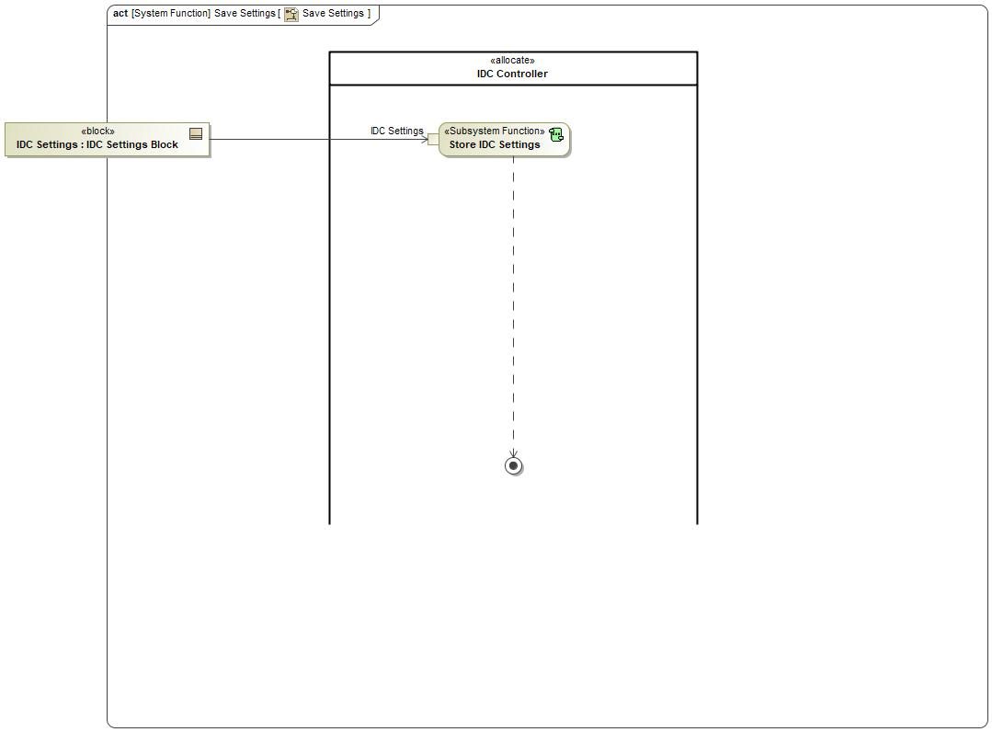

Figure : Activity Diagram of -1718407727.jpg “Save Settings” calling -152244866.jpg “Store IDC Settings”

### Function Interfaces

#### Logical Inputs

|  |  |
| --- | --- |
| **Signal Name** | **Description** |
| IDC Settings  Type:  -1837289285.jpg IDC Settings Block |  |

#### Logical Outputs

No Logical Outputs specified.

#### Logical Parameters

*Not supported by MagicDraw report generation.*

|  |  |
| --- | --- |
| **Parameter Name** | **Description** |
| <(Mandatory) Word reference to the “Logical Parameters” name bookmark in the Data Dictionary> | <(Optional) Word reference to the “Logical Parameters” description bookmark in the Data Dictionary> |
|  |  |

### Function Modeling

#### Use Cases

*Not supported by MagicDraw report generation.*

#### State Charts

No state chart associated to specified function.

#### Activity Diagrams

No activity diagram associated to specified function.

#### Sequence Diagrams

No sequence diagram associated to specified function.

#### Decision Tables

### Function Requirements

#### Functional Requirements

##### Normal Operation

FNC_SSR_008 Store IDC Settings

IDC Controller shall store IDC Settings.

|  |  |  |  |  |  |  |  |
| --- | --- | --- | --- | --- | --- | --- | --- |
| Requirement ID: FNC_SSR_008 | | | | | | | |
| **Rationale** |  | | | | | | |
| **Acceptance Criteria** | To be written by Malik. | | | | | | |
| **Notes** |  | | | | | | |
| **Source** | To be written by Malik. | | | | | **Owner** | Malik Eteer |
| **Source Req.** | * 337127062.jpg F_HMI_001 Camera Settings * 337127062.jpg F_IF_0012 IDC Settings at Vehicle Wake-Up | | | | | **V&V Method** |  |
| **Type** |  | | | **Priority** | 1 | **Status** |  |
| [Req. Template](http://wiki.ford.com/display/RequirementsEngineering/Requirements+Attributes) Version | | 6.0 | End of Requirement | | | | |

##### Error Handling

No Error Handling Requirements specified.

#### Non-Functional Requirements

No Non-Functional Requirements specified.

#### Functional Safety Requirements

No Functional Safety Requirements specified.

#### Other Requirements

##### Design Requirements

No Design Requirements specified.

## Logical Function -1718407727.jpg Mark As Read Only HMI

### Function Overview

#### Function Description

Function is allocated to:

* 510254531.jpg HMI System <<Logical>>

No description provided for this function.

#### Function Variants

*Not supported by MagicDraw report generation.*

|  |  |  |
| --- | --- | --- |
| Variant Name | Variant Description | Variant Condition (optional) |
| e.g. “High Content” |  | e.g. ExtLightTechnology = LED  OR  ExtLightTechnology = Xenon |

#### Input Requirements/Documents

|  |  |  |  |
| --- | --- | --- | --- |
| **Reference**  (Reference as listed in ch. ”References”) | **Section/Requirement** | **Description** | **Derived Requirement**  (optional – reference to requirement in ch. “Function Requirements”) |
| **Feature Requirements** | | | |
|  | <Example:  id + title of relevant Feature Docs> | <Example: “Requirements of Feature …”> | <Note: If you reference a requirement in this column, that requirement should have a trace link in its [“Source”/”Source Req.” attribute](http://wiki.ford.com/display/RequirementsEngineering/Requirements+Attributes) field pointing back to the input requirement (or to a requirement inside the input document) given in this table row> |
|  |  |  |  |
| **Ford Engineering Standards** | | | |
|  | <Example: some SDS (requirement)> |  |  |
|  |  |  |  |
| **Legal Regulations** | | | |
|  | Compliance with FMVSS111 | IDC shall adhere to rear view image regulation as described in FMVSS 111. |  |
|  | Compliance with FMVSS101 | IDC display shall adhere to user visibility described in FMVSS 101. |  |
|  |  |  |  |
| **Industry Standards** | | | |
|  | ISO 26262 | IDC shall be developed according to Ford's Implementation of Functional Safety (IDC qualified as QM/new changes will require new analysis). |  |
|  |  |  |  |
| **Other Sources** | | | |
|  |  |  |  |
|  |  |  |  |

Table 7: Input Requirements/Documents

#### Assumptions

No assumptions specified for this function.

### Function Scope

The -1718407727.jpg **– “Mark As Read Only HMI”** function is called by the following functions:

* -1011707753.jpg – “Record Videos/Data”



Figure : Activity Diagram of -1011707753.jpg “Record Videos/Data” calling -1718407727.jpg “Mark As Read Only HMI”

### Function Interfaces

#### Logical Inputs

No Logical Inputs specified.

#### Logical Outputs

No Logical Outputs specified.

#### Logical Parameters

*Not supported by MagicDraw report generation.*

|  |  |
| --- | --- |
| **Parameter Name** | **Description** |
| <(Mandatory) Word reference to the “Logical Parameters” name bookmark in the Data Dictionary> | <(Optional) Word reference to the “Logical Parameters” description bookmark in the Data Dictionary> |
|  |  |

### Function Modeling

#### Use Cases

*Not supported by MagicDraw report generation.*

#### State Charts

No state chart associated to specified function.

#### Activity Diagrams

No activity diagram associated to specified function.

#### Sequence Diagrams

No sequence diagram associated to specified function.

#### Decision Tables

### Function Requirements

#### Functional Requirements

##### Normal Operation

No Normal Operation Requirements specified.

##### Error Handling

No Error Handling Requirements specified.

#### Non-Functional Requirements

No Non-Functional Requirements specified.

#### Functional Safety Requirements

No Functional Safety Requirements specified.

#### Other Requirements

##### Design Requirements

No Design Requirements specified.

#### Uncategorized Requirements

F_SR_003 Selected Video Marked As Read Only

HMI system shall inform user that the video selected is in a READ ONLY state.

|  |  |  |  |  |  |  |  |
| --- | --- | --- | --- | --- | --- | --- | --- |
| Requirement ID: F_SR_003 | | | | | | | |
| **Rationale** |  | | | | | | |
| **Acceptance Criteria** | To be written by Malik. | | | | | | |
| **Notes** |  | | | | | | |
| **Source** | To be written by Malik. | | | | | **Owner** | Malik Eteer |
| **Source Req.** | * 337127062.jpg F_HMI_006 Vehicle Data convert files to read only during playback * 337127062.jpg F_HMI_007 Vehicle Data convert files to read only on demand * 337127062.jpg F_IF_005 Recorded Files to READ ONLY on Command * 337127062.jpg F_IF_006 Recorded Files to READ ONLY Based on Sensor Exceeding user Threshold Settings | | | | | **V&V Method** |  |
| **Type** |  | | | **Priority** | 1 | **Status** |  |
| [Req. Template](http://wiki.ford.com/display/RequirementsEngineering/Requirements+Attributes) Version | | 6.0 | End of Requirement | | | | |

## Logical Function -1718407727.jpg Display Settings

### Function Overview

#### Function Description

Function is allocated to:

* 510254531.jpg HMI System <<Logical>>
* 510254531.jpg IVI System <<Logical>>

No description provided for this function.

#### Function Variants

*Not supported by MagicDraw report generation.*

|  |  |  |
| --- | --- | --- |
| Variant Name | Variant Description | Variant Condition (optional) |
| e.g. “High Content” |  | e.g. ExtLightTechnology = LED  OR  ExtLightTechnology = Xenon |

#### Input Requirements/Documents

|  |  |  |  |
| --- | --- | --- | --- |
| **Reference**  (Reference as listed in ch. ”References”) | **Section/Requirement** | **Description** | **Derived Requirement**  (optional – reference to requirement in ch. “Function Requirements”) |
| **Feature Requirements** | | | |
|  | <Example:  id + title of relevant Feature Docs> | <Example: “Requirements of Feature …”> | <Note: If you reference a requirement in this column, that requirement should have a trace link in its [“Source”/”Source Req.” attribute](http://wiki.ford.com/display/RequirementsEngineering/Requirements+Attributes) field pointing back to the input requirement (or to a requirement inside the input document) given in this table row> |
|  |  |  |  |
| **Ford Engineering Standards** | | | |
|  | <Example: some SDS (requirement)> |  |  |
|  |  |  |  |
| **Legal Regulations** | | | |
|  | Compliance with FMVSS111 | IDC shall adhere to rear view image regulation as described in FMVSS 111. |  |
|  | Compliance with FMVSS101 | IDC display shall adhere to user visibility described in FMVSS 101. |  |
|  |  |  |  |
| **Industry Standards** | | | |
|  | ISO 26262 | IDC shall be developed according to Ford's Implementation of Functional Safety (IDC qualified as QM/new changes will require new analysis). |  |
|  |  |  |  |
| **Other Sources** | | | |
|  |  |  |  |
|  |  |  |  |

Table 7: Input Requirements/Documents

#### Assumptions

No assumptions specified for this function.

### Function Scope

The -1718407727.jpg **– “Display Settings”** function is called by the following functions:

* -1011707753.jpg – “Update IDC Settings”



Figure : Activity Diagram of -1011707753.jpg “Update IDC Settings” calling -1718407727.jpg “Display Settings”

### Function Interfaces

#### Logical Inputs

|  |  |
| --- | --- |
| **Signal Name** | **Description** |
| IDC Settings  Type:  -1837289285.jpg IDC Settings Block | Received from:   * -1718407727.jpg Retrieve Settings |

#### Logical Outputs

|  |  |
| --- | --- |
| **Signal Name** | **Description** |
| IDC Settings  Type:  -1837289285.jpg IDC Settings Block | Sent to:   * -1718407727.jpg Update Settings |

#### Logical Parameters

*Not supported by MagicDraw report generation.*

|  |  |
| --- | --- |
| **Parameter Name** | **Description** |
| <(Mandatory) Word reference to the “Logical Parameters” name bookmark in the Data Dictionary> | <(Optional) Word reference to the “Logical Parameters” description bookmark in the Data Dictionary> |
|  |  |

### Function Modeling

#### Use Cases

*Not supported by MagicDraw report generation.*

#### State Charts

No state chart associated to specified function.

#### Activity Diagrams

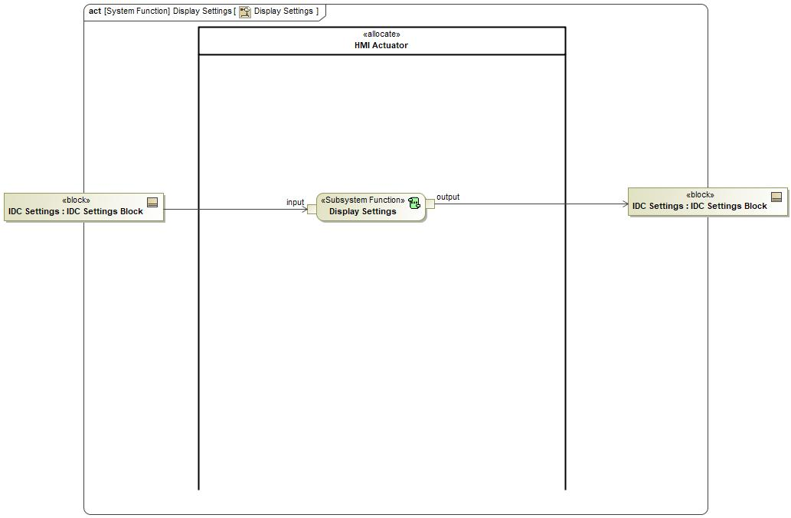

Figure 5: Display Settings

#### Sequence Diagrams

No sequence diagram associated to specified function.

#### Decision Tables

### Function Requirements

#### Functional Requirements

##### Normal Operation

No Normal Operation Requirements specified.

##### Error Handling

No Error Handling Requirements specified.

#### Non-Functional Requirements

No Non-Functional Requirements specified.

#### Functional Safety Requirements

No Functional Safety Requirements specified.

#### Other Requirements

##### Design Requirements

No Design Requirements specified.

#### Uncategorized Requirements

F_SR_0011 Display Setting Updates

HMI system shall display the updated settings for the video recording.

|  |  |  |  |  |  |  |  |
| --- | --- | --- | --- | --- | --- | --- | --- |
| Requirement ID: F_SR_0011 | | | | | | | |
| **Rationale** |  | | | | | | |
| **Acceptance Criteria** | To be written by Malik. | | | | | | |
| **Notes** |  | | | | | | |
| **Source** | To be written by Malik. | | | | | **Owner** | Malik Eteer |
| **Source Req.** | * 337127062.jpg F_HMI_001 Camera Settings * 337127062.jpg F_HMI_008 Vehicle Data Settings * 337127062.jpg F_IF_007 Set Vehicle Data Recording Settings | | | | | **V&V Method** |  |
| **Type** |  | | | **Priority** | 1 | **Status** |  |
| [Req. Template](http://wiki.ford.com/display/RequirementsEngineering/Requirements+Attributes) Version | | 6.0 | End of Requirement | | | | |

## Logical Function -152244866.jpg Use Default Settings

### Function Overview

#### Function Description

Function is allocated to:

* 510254531.jpg HMI Actuator <<Logical>>
* 510254531.jpg IDC Controller <<Logical>>
* 510254531.jpg IVI System <<Logical>>

No description provided for this function.

#### Function Variants

*Not supported by MagicDraw report generation.*

|  |  |  |
| --- | --- | --- |
| Variant Name | Variant Description | Variant Condition (optional) |
| e.g. “High Content” |  | e.g. ExtLightTechnology = LED  OR  ExtLightTechnology = Xenon |

#### Input Requirements/Documents

|  |  |  |  |
| --- | --- | --- | --- |
| **Reference**  (Reference as listed in ch. ”References”) | **Section/Requirement** | **Description** | **Derived Requirement**  (optional – reference to requirement in ch. “Function Requirements”) |
| **Feature Requirements** | | | |
|  | <Example:  id + title of relevant Feature Docs> | <Example: “Requirements of Feature …”> | <Note: If you reference a requirement in this column, that requirement should have a trace link in its [“Source”/”Source Req.” attribute](http://wiki.ford.com/display/RequirementsEngineering/Requirements+Attributes) field pointing back to the input requirement (or to a requirement inside the input document) given in this table row> |
|  |  |  |  |
| **Ford Engineering Standards** | | | |
|  | <Example: some SDS (requirement)> |  |  |
|  |  |  |  |
| **Legal Regulations** | | | |
|  | Compliance with FMVSS111 | IDC shall adhere to rear view image regulation as described in FMVSS 111. |  |
|  | Compliance with FMVSS101 | IDC display shall adhere to user visibility described in FMVSS 101. |  |
|  |  |  |  |
| **Industry Standards** | | | |
|  | ISO 26262 | IDC shall be developed according to Ford's Implementation of Functional Safety (IDC qualified as QM/new changes will require new analysis). |  |
|  |  |  |  |
| **Other Sources** | | | |
|  |  |  |  |
|  |  |  |  |

Table 7: Input Requirements/Documents

#### Assumptions

No assumptions specified for this function.

### Function Scope

The -152244866.jpg **– “Use Default Settings”** function is called by the following functions:

* -1718407727.jpg – “Retrieve Settings”



Figure : Activity Diagram of -1718407727.jpg “Retrieve Settings” calling -152244866.jpg “Use Default Settings”

### Function Interfaces

#### Logical Inputs

No Logical Inputs specified.

#### Logical Outputs

|  |  |
| --- | --- |
| **Signal Name** | **Description** |
| Default IDC Settings  Type:  -1837289285.jpg IDC Settings Block |  |

#### Logical Parameters

*Not supported by MagicDraw report generation.*

|  |  |
| --- | --- |
| **Parameter Name** | **Description** |
| <(Mandatory) Word reference to the “Logical Parameters” name bookmark in the Data Dictionary> | <(Optional) Word reference to the “Logical Parameters” description bookmark in the Data Dictionary> |
|  |  |

### Function Modeling

#### Use Cases

*Not supported by MagicDraw report generation.*

#### State Charts

No state chart associated to specified function.

#### Activity Diagrams

No activity diagram associated to specified function.

#### Sequence Diagrams

No sequence diagram associated to specified function.

#### Decision Tables

### Function Requirements

#### Functional Requirements

##### Normal Operation

No Normal Operation Requirements specified.

##### Error Handling

No Error Handling Requirements specified.

#### Non-Functional Requirements

No Non-Functional Requirements specified.

#### Functional Safety Requirements

No Functional Safety Requirements specified.

#### Other Requirements

##### Design Requirements

No Design Requirements specified.

#### Uncategorized Requirements

FNC_SSR_002 Use Stored/Default Settings

When IDC starts, HMI Controller will attempt to retrieve stored settings from previous ignition cycle:

1. If found, use retrieved stored settings.

2. If not found, use default settings.

|  |  |  |  |  |  |  |  |
| --- | --- | --- | --- | --- | --- | --- | --- |
| Requirement ID: FNC_SSR_002 | | | | | | | |
| **Rationale** |  | | | | | | |
| **Acceptance Criteria** | To be written by Malik. | | | | | | |
| **Notes** |  | | | | | | |
| **Source** | To be written by Malik. | | | | | **Owner** | Malik Eteer |
| **Source Req.** | * 337127062.jpg F_HMI_001 Camera Settings * 337127062.jpg F_IF_0012 IDC Settings at Vehicle Wake-Up | | | | | **V&V Method** |  |
| **Type** |  | | | **Priority** | 1 | **Status** |  |
| [Req. Template](http://wiki.ford.com/display/RequirementsEngineering/Requirements+Attributes) Version | | 6.0 | End of Requirement | | | | |

## Logical Function -1718407727.jpg Issue A Read Only Flag

### Function Overview

#### Function Description

Function is allocated to:

* 510254531.jpg IVI System <<Logical>>

No description provided for this function.

#### Function Variants

*Not supported by MagicDraw report generation.*

|  |  |  |
| --- | --- | --- |
| Variant Name | Variant Description | Variant Condition (optional) |
| e.g. “High Content” |  | e.g. ExtLightTechnology = LED  OR  ExtLightTechnology = Xenon |

#### Input Requirements/Documents

|  |  |  |  |
| --- | --- | --- | --- |
| **Reference**  (Reference as listed in ch. ”References”) | **Section/Requirement** | **Description** | **Derived Requirement**  (optional – reference to requirement in ch. “Function Requirements”) |
| **Feature Requirements** | | | |
|  | <Example:  id + title of relevant Feature Docs> | <Example: “Requirements of Feature …”> | <Note: If you reference a requirement in this column, that requirement should have a trace link in its [“Source”/”Source Req.” attribute](http://wiki.ford.com/display/RequirementsEngineering/Requirements+Attributes) field pointing back to the input requirement (or to a requirement inside the input document) given in this table row> |
|  |  |  |  |
| **Ford Engineering Standards** | | | |
|  | <Example: some SDS (requirement)> |  |  |
|  |  |  |  |
| **Legal Regulations** | | | |
|  | Compliance with FMVSS111 | IDC shall adhere to rear view image regulation as described in FMVSS 111. |  |
|  | Compliance with FMVSS101 | IDC display shall adhere to user visibility described in FMVSS 101. |  |
|  |  |  |  |
| **Industry Standards** | | | |
|  | ISO 26262 | IDC shall be developed according to Ford's Implementation of Functional Safety (IDC qualified as QM/new changes will require new analysis). |  |
|  |  |  |  |
| **Other Sources** | | | |
|  |  |  |  |
|  |  |  |  |

Table 7: Input Requirements/Documents

#### Assumptions

No assumptions specified for this function.

### Function Scope

The -1718407727.jpg **– “Issue A Read Only Flag”** function is called by the following functions:

* 1904812737.jpg – “Record Videos/Data”



Figure : Activity Diagram of 1904812737.jpg “Record Videos/Data” calling -1718407727.jpg “Issue A Read Only Flag”

### Function Interfaces

#### Logical Inputs

No Logical Inputs specified.

#### Logical Outputs

|  |  |
| --- | --- |
| **Signal Name** | **Description** |
| Read Only Flag  Type:  -2109356987.jpg Read Only Flag |  |

#### Logical Parameters

*Not supported by MagicDraw report generation.*

|  |  |
| --- | --- |
| **Parameter Name** | **Description** |
| <(Mandatory) Word reference to the “Logical Parameters” name bookmark in the Data Dictionary> | <(Optional) Word reference to the “Logical Parameters” description bookmark in the Data Dictionary> |
|  |  |

### Function Modeling

#### Use Cases

*Not supported by MagicDraw report generation.*

#### State Charts

No state chart associated to specified function.

#### Activity Diagrams

No activity diagram associated to specified function.

#### Sequence Diagrams

No sequence diagram associated to specified function.

#### Decision Tables

### Function Requirements

#### Functional Requirements

##### Normal Operation

F_SR_0021 IVI System Issues A Read Only Flag

IVI system shall issue a READ ONLY flag should an event be detected or the user has selected that the video be locked for editing.

|  |  |  |  |  |  |  |  |
| --- | --- | --- | --- | --- | --- | --- | --- |
| Requirement ID: F_SR_0021 | | | | | | | |
| **Rationale** |  | | | | | | |
| **Acceptance Criteria** | To be written by Malik. | | | | | | |
| **Notes** |  | | | | | | |
| **Source** | To be written by Malik. | | | | | **Owner** | Malik Eteer |
| **Source Req.** | * 337127062.jpg F_IF_005 Recorded Files to READ ONLY on Command * 337127062.jpg F_IF_006 Recorded Files to READ ONLY Based on Sensor Exceeding user Threshold Settings | | | | | **V&V Method** |  |
| **Type** |  | | | **Priority** | 1 | **Status** |  |
| [Req. Template](http://wiki.ford.com/display/RequirementsEngineering/Requirements+Attributes) Version | | 6.0 | End of Requirement | | | | |

##### Error Handling

No Error Handling Requirements specified.

#### Non-Functional Requirements

No Non-Functional Requirements specified.

#### Functional Safety Requirements

No Functional Safety Requirements specified.

#### Other Requirements

##### Design Requirements

No Design Requirements specified.

## Logical Function 1851368034.jpg Save Settings

### Function Overview

#### Function Description

Function is allocated to:

* 510254531.jpg HMI System <<Logical>>

No description provided for this function.

#### Function Variants

*Not supported by MagicDraw report generation.*

|  |  |  |
| --- | --- | --- |
| Variant Name | Variant Description | Variant Condition (optional) |
| e.g. “High Content” |  | e.g. ExtLightTechnology = LED  OR  ExtLightTechnology = Xenon |

#### Input Requirements/Documents

|  |  |  |  |
| --- | --- | --- | --- |
| **Reference**  (Reference as listed in ch. ”References”) | **Section/Requirement** | **Description** | **Derived Requirement**  (optional – reference to requirement in ch. “Function Requirements”) |
| **Feature Requirements** | | | |
|  | <Example:  id + title of relevant Feature Docs> | <Example: “Requirements of Feature …”> | <Note: If you reference a requirement in this column, that requirement should have a trace link in its [“Source”/”Source Req.” attribute](http://wiki.ford.com/display/RequirementsEngineering/Requirements+Attributes) field pointing back to the input requirement (or to a requirement inside the input document) given in this table row> |
|  |  |  |  |
| **Ford Engineering Standards** | | | |
|  | <Example: some SDS (requirement)> |  |  |
|  |  |  |  |
| **Legal Regulations** | | | |
|  | Compliance with FMVSS111 | IDC shall adhere to rear view image regulation as described in FMVSS 111. |  |
|  | Compliance with FMVSS101 | IDC display shall adhere to user visibility described in FMVSS 101. |  |
|  |  |  |  |
| **Industry Standards** | | | |
|  | ISO 26262 | IDC shall be developed according to Ford's Implementation of Functional Safety (IDC qualified as QM/new changes will require new analysis). |  |
|  |  |  |  |
| **Other Sources** | | | |
|  |  |  |  |
|  |  |  |  |

Table 7: Input Requirements/Documents

#### Assumptions

No assumptions specified for this function.

### Function Scope

The 1851368034.jpg **– “Save Settings”** function is called by the following functions:

* 1904812737.jpg – “Update IDC Settings”



Figure : Activity Diagram of 1904812737.jpg “Update IDC Settings” calling 1851368034.jpg “Save Settings”

### Function Interfaces

#### Logical Inputs

|  |  |
| --- | --- |
| **Signal Name** | **Description** |
| IDC Settings  Type:  -1837289285.jpg IDC Settings Block | Received from:   * 1851368034.jpg Update Settings |

#### Logical Outputs

No Logical Outputs specified.

#### Logical Parameters

*Not supported by MagicDraw report generation.*

|  |  |
| --- | --- |
| **Parameter Name** | **Description** |
| <(Mandatory) Word reference to the “Logical Parameters” name bookmark in the Data Dictionary> | <(Optional) Word reference to the “Logical Parameters” description bookmark in the Data Dictionary> |
|  |  |

### Function Modeling

#### Use Cases

*Not supported by MagicDraw report generation.*

#### State Charts

No state chart associated to specified function.

#### Activity Diagrams



Figure 5: Save Settings

#### Sequence Diagrams

No sequence diagram associated to specified function.

#### Decision Tables

### Function Requirements

#### Functional Requirements

##### Normal Operation

No Normal Operation Requirements specified.

##### Error Handling

No Error Handling Requirements specified.

#### Non-Functional Requirements

No Non-Functional Requirements specified.

#### Functional Safety Requirements

No Functional Safety Requirements specified.

#### Other Requirements

##### Design Requirements

No Design Requirements specified.

#### Uncategorized Requirements

F_SR_005 HMI Save Settings Selection

HMI system shall provide an HMI selection to save the updated display settings for the video recording.

|  |  |  |  |  |  |  |  |
| --- | --- | --- | --- | --- | --- | --- | --- |
| Requirement ID: F_SR_005 | | | | | | | |
| **Rationale** |  | | | | | | |
| **Acceptance Criteria** | To be written by Malik. | | | | | | |
| **Notes** |  | | | | | | |
| **Source** | To be written by Malik. | | | | | **Owner** | Malik Eteer |
| **Source Req.** | * 337127062.jpg F_HMI_0013 HMI Save Updated Setting | | | | | **V&V Method** |  |
| **Type** |  | | | **Priority** | 1 | **Status** |  |
| [Req. Template](http://wiki.ford.com/display/RequirementsEngineering/Requirements+Attributes) Version | | 6.0 | End of Requirement | | | | |

## Logical Function -888232662.jpg Display Settings

### Function Overview

#### Function Description

Function is allocated to:

* 510254531.jpg HMI Actuator <<Logical>>

No description provided for this function.

#### Function Variants

*Not supported by MagicDraw report generation.*

|  |  |  |
| --- | --- | --- |
| Variant Name | Variant Description | Variant Condition (optional) |
| e.g. “High Content” |  | e.g. ExtLightTechnology = LED  OR  ExtLightTechnology = Xenon |

#### Input Requirements/Documents

|  |  |  |  |
| --- | --- | --- | --- |
| **Reference**  (Reference as listed in ch. ”References”) | **Section/Requirement** | **Description** | **Derived Requirement**  (optional – reference to requirement in ch. “Function Requirements”) |
| **Feature Requirements** | | | |
|  | <Example:  id + title of relevant Feature Docs> | <Example: “Requirements of Feature …”> | <Note: If you reference a requirement in this column, that requirement should have a trace link in its [“Source”/”Source Req.” attribute](http://wiki.ford.com/display/RequirementsEngineering/Requirements+Attributes) field pointing back to the input requirement (or to a requirement inside the input document) given in this table row> |
|  |  |  |  |
| **Ford Engineering Standards** | | | |
|  | <Example: some SDS (requirement)> |  |  |
|  |  |  |  |
| **Legal Regulations** | | | |
|  | Compliance with FMVSS111 | IDC shall adhere to rear view image regulation as described in FMVSS 111. |  |
|  | Compliance with FMVSS101 | IDC display shall adhere to user visibility described in FMVSS 101. |  |
|  |  |  |  |
| **Industry Standards** | | | |
|  | ISO 26262 | IDC shall be developed according to Ford's Implementation of Functional Safety (IDC qualified as QM/new changes will require new analysis). |  |
|  |  |  |  |
| **Other Sources** | | | |
|  |  |  |  |
|  |  |  |  |

Table 7: Input Requirements/Documents

#### Assumptions

No assumptions specified for this function.

### Function Scope

The -888232662.jpg **– “Display Settings”** function is called by the following functions:

* 1851368034.jpg – “Display Settings”



Figure : Activity Diagram of 1851368034.jpg “Display Settings” calling -888232662.jpg “Display Settings”

### Function Interfaces

#### Logical Inputs

|  |  |
| --- | --- |
| **Signal Name** | **Description** |
| input  Type:  -1837289285.jpg IDC Settings Block |  |

#### Logical Outputs

|  |  |
| --- | --- |
| **Signal Name** | **Description** |
| output  Type:  -1837289285.jpg IDC Settings Block |  |

#### Logical Parameters

*Not supported by MagicDraw report generation.*

|  |  |
| --- | --- |
| **Parameter Name** | **Description** |
| <(Mandatory) Word reference to the “Logical Parameters” name bookmark in the Data Dictionary> | <(Optional) Word reference to the “Logical Parameters” description bookmark in the Data Dictionary> |
|  |  |

### Function Modeling

#### Use Cases

*Not supported by MagicDraw report generation.*

#### State Charts

No state chart associated to specified function.

#### Activity Diagrams

No activity diagram associated to specified function.

#### Sequence Diagrams

No sequence diagram associated to specified function.

#### Decision Tables

### Function Requirements

#### Functional Requirements

##### Normal Operation

No Normal Operation Requirements specified.

##### Error Handling

No Error Handling Requirements specified.

#### Non-Functional Requirements

No Non-Functional Requirements specified.

#### Functional Safety Requirements

No Functional Safety Requirements specified.

#### Other Requirements

##### Design Requirements

No Design Requirements specified.

#### Uncategorized Requirements

FNC_SSR_003 Display Settings

HMI Actuator shall allow IDC to display settings for user selection.

|  |  |  |  |  |  |  |  |
| --- | --- | --- | --- | --- | --- | --- | --- |
| Requirement ID: FNC_SSR_003 | | | | | | | |
| **Rationale** |  | | | | | | |
| **Acceptance Criteria** | To be written by Malik. | | | | | | |
| **Notes** |  | | | | | | |
| **Source** | To be written by Malik. | | | | | **Owner** | Malik Eteer |
| **Source Req.** | * 337127062.jpg F_HMI_001 Camera Settings * 337127062.jpg F_IF_0012 IDC Settings at Vehicle Wake-Up | | | | | **V&V Method** |  |
| **Type** |  | | | **Priority** | 1 | **Status** |  |
| [Req. Template](http://wiki.ford.com/display/RequirementsEngineering/Requirements+Attributes) Version | | 6.0 | End of Requirement | | | | |

## Logical Function -888232662.jpg Set Recording Settings Status

### Function Overview

#### Function Description

Function is allocated to:

* 510254531.jpg HMI Controller <<Logical>>

No description provided for this function.

#### Function Variants

*Not supported by MagicDraw report generation.*

|  |  |  |
| --- | --- | --- |
| Variant Name | Variant Description | Variant Condition (optional) |
| e.g. “High Content” |  | e.g. ExtLightTechnology = LED  OR  ExtLightTechnology = Xenon |

#### Input Requirements/Documents

|  |  |  |  |
| --- | --- | --- | --- |
| **Reference**  (Reference as listed in ch. ”References”) | **Section/Requirement** | **Description** | **Derived Requirement**  (optional – reference to requirement in ch. “Function Requirements”) |
| **Feature Requirements** | | | |
|  | <Example:  id + title of relevant Feature Docs> | <Example: “Requirements of Feature …”> | <Note: If you reference a requirement in this column, that requirement should have a trace link in its [“Source”/”Source Req.” attribute](http://wiki.ford.com/display/RequirementsEngineering/Requirements+Attributes) field pointing back to the input requirement (or to a requirement inside the input document) given in this table row> |
|  |  |  |  |
| **Ford Engineering Standards** | | | |
|  | <Example: some SDS (requirement)> |  |  |
|  |  |  |  |
| **Legal Regulations** | | | |
|  | Compliance with FMVSS111 | IDC shall adhere to rear view image regulation as described in FMVSS 111. |  |
|  | Compliance with FMVSS101 | IDC display shall adhere to user visibility described in FMVSS 101. |  |
|  |  |  |  |
| **Industry Standards** | | | |
|  | ISO 26262 | IDC shall be developed according to Ford's Implementation of Functional Safety (IDC qualified as QM/new changes will require new analysis). |  |
|  |  |  |  |
| **Other Sources** | | | |
|  |  |  |  |
|  |  |  |  |

Table 7: Input Requirements/Documents

#### Assumptions

No assumptions specified for this function.

### Function Scope

The -888232662.jpg **– “Set Recording Settings Status”** function is called by the following functions:

* 1851368034.jpg – “Update Settings”



Figure : Activity Diagram of 1851368034.jpg “Add New Settings” calling -888232662.jpg “Set Recording Settings Status”

### Function Interfaces

#### Logical Inputs

|  |  |
| --- | --- |
| **Signal Name** | **Description** |
| IDC Settings  Type:  -1837289285.jpg IDC Settings Block |  |
| HMI Selections |  |

#### Logical Outputs

|  |  |
| --- | --- |
| **Signal Name** | **Description** |
| IDC Settings  Type:  -1837289285.jpg IDC Settings Block |  |

#### Logical Parameters

*Not supported by MagicDraw report generation.*

|  |  |
| --- | --- |
| **Parameter Name** | **Description** |
| <(Mandatory) Word reference to the “Logical Parameters” name bookmark in the Data Dictionary> | <(Optional) Word reference to the “Logical Parameters” description bookmark in the Data Dictionary> |
|  |  |

### Function Modeling

#### Use Cases

*Not supported by MagicDraw report generation.*

#### State Charts

No state chart associated to specified function.

#### Activity Diagrams

No activity diagram associated to specified function.

#### Sequence Diagrams

No sequence diagram associated to specified function.

#### Decision Tables

### Function Requirements

#### Functional Requirements

##### Normal Operation

No Normal Operation Requirements specified.

##### Error Handling

No Error Handling Requirements specified.

#### Non-Functional Requirements

No Non-Functional Requirements specified.

#### Functional Safety Requirements

No Functional Safety Requirements specified.

#### Other Requirements

##### Design Requirements

No Design Requirements specified.

#### Uncategorized Requirements

FNC_SSR_0010 Set Recording Settings Status

HMI Controller shall allow user to make selections to alter IDC settings such as recording status, g-sensor, loop recording, video recording, GPS logging, pedal position, and vehicle speed.

|  |  |  |  |  |  |  |  |
| --- | --- | --- | --- | --- | --- | --- | --- |
| Requirement ID: FNC_SSR_0010 | | | | | | | |
| **Rationale** |  | | | | | | |
| **Acceptance Criteria** | To be written by Malik. | | | | | | |
| **Notes** |  | | | | | | |
| **Source** | To be written by Malik. | | | | | **Owner** | Malik Eteer |
| **Source Req.** | * 337127062.jpg F_HMI_001 Camera Settings * 337127062.jpg F_IF_0012 IDC Settings at Vehicle Wake-Up | | | | | **V&V Method** |  |
| **Type** |  | | | **Priority** | 1 | **Status** |  |
| [Req. Template](http://wiki.ford.com/display/RequirementsEngineering/Requirements+Attributes) Version | | 6.0 | End of Requirement | | | | |

## Logical Function -888232662.jpg Set Pedal Position

### Function Overview

#### Function Description

Function is allocated to:

* 510254531.jpg HMI Controller <<Logical>>

No description provided for this function.

#### Function Variants

*Not supported by MagicDraw report generation.*

|  |  |  |
| --- | --- | --- |
| Variant Name | Variant Description | Variant Condition (optional) |
| e.g. “High Content” |  | e.g. ExtLightTechnology = LED  OR  ExtLightTechnology = Xenon |

#### Input Requirements/Documents

|  |  |  |  |
| --- | --- | --- | --- |
| **Reference**  (Reference as listed in ch. ”References”) | **Section/Requirement** | **Description** | **Derived Requirement**  (optional – reference to requirement in ch. “Function Requirements”) |
| **Feature Requirements** | | | |
|  | <Example:  id + title of relevant Feature Docs> | <Example: “Requirements of Feature …”> | <Note: If you reference a requirement in this column, that requirement should have a trace link in its [“Source”/”Source Req.” attribute](http://wiki.ford.com/display/RequirementsEngineering/Requirements+Attributes) field pointing back to the input requirement (or to a requirement inside the input document) given in this table row> |
|  |  |  |  |
| **Ford Engineering Standards** | | | |
|  | <Example: some SDS (requirement)> |  |  |
|  |  |  |  |
| **Legal Regulations** | | | |
|  | Compliance with FMVSS111 | IDC shall adhere to rear view image regulation as described in FMVSS 111. |  |
|  | Compliance with FMVSS101 | IDC display shall adhere to user visibility described in FMVSS 101. |  |
|  |  |  |  |
| **Industry Standards** | | | |
|  | ISO 26262 | IDC shall be developed according to Ford's Implementation of Functional Safety (IDC qualified as QM/new changes will require new analysis). |  |
|  |  |  |  |
| **Other Sources** | | | |
|  |  |  |  |
|  |  |  |  |

Table 7: Input Requirements/Documents

#### Assumptions

No assumptions specified for this function.

### Function Scope

The -888232662.jpg **– “Set Pedal Position”** function is called by the following functions:

* 1851368034.jpg – “Update Settings”



Figure : Activity Diagram of 1851368034.jpg “Add New Settings” calling -888232662.jpg “Set Pedal Position”

### Function Interfaces

#### Logical Inputs

|  |  |
| --- | --- |
| **Signal Name** | **Description** |
| HMI Selections  Type:  -1837289285.jpg HMI Selections Block |  |
| IDC Settings  Type:  -1837289285.jpg IDC Settings Block |  |

#### Logical Outputs

|  |  |
| --- | --- |
| **Signal Name** | **Description** |
| IDC Settings  Type:  -2109356987.jpg Overlay Settings |  |

#### Logical Parameters

*Not supported by MagicDraw report generation.*

|  |  |
| --- | --- |
| **Parameter Name** | **Description** |
| <(Mandatory) Word reference to the “Logical Parameters” name bookmark in the Data Dictionary> | <(Optional) Word reference to the “Logical Parameters” description bookmark in the Data Dictionary> |
|  |  |

### Function Modeling

#### Use Cases

*Not supported by MagicDraw report generation.*

#### State Charts

No state chart associated to specified function.

#### Activity Diagrams

No activity diagram associated to specified function.

#### Sequence Diagrams

No sequence diagram associated to specified function.

#### Decision Tables

### Function Requirements

#### Functional Requirements

##### Normal Operation

No Normal Operation Requirements specified.

##### Error Handling

No Error Handling Requirements specified.

#### Non-Functional Requirements

No Non-Functional Requirements specified.

#### Functional Safety Requirements

No Functional Safety Requirements specified.

#### Other Requirements

##### Design Requirements

No Design Requirements specified.

#### Uncategorized Requirements

FNC_SSR_0010 Set Recording Settings Status

HMI Controller shall allow user to make selections to alter IDC settings such as recording status, g-sensor, loop recording, video recording, GPS logging, pedal position, and vehicle speed.

|  |  |  |  |  |  |  |  |
| --- | --- | --- | --- | --- | --- | --- | --- |
| Requirement ID: FNC_SSR_0010 | | | | | | | |
| **Rationale** |  | | | | | | |
| **Acceptance Criteria** | To be written by Malik. | | | | | | |
| **Notes** |  | | | | | | |
| **Source** | To be written by Malik. | | | | | **Owner** | Malik Eteer |
| **Source Req.** | * 337127062.jpg F_HMI_001 Camera Settings * 337127062.jpg F_IF_0012 IDC Settings at Vehicle Wake-Up | | | | | **V&V Method** |  |
| **Type** |  | | | **Priority** | 1 | **Status** |  |
| [Req. Template](http://wiki.ford.com/display/RequirementsEngineering/Requirements+Attributes) Version | | 6.0 | End of Requirement | | | | |

## Logical Function -888232662.jpg Receive Media Storage Status

### Function Overview

#### Function Description

Function is allocated to:

* 510254531.jpg IDC Controller <<Logical>>

No description provided for this function.

#### Function Variants

*Not supported by MagicDraw report generation.*

|  |  |  |
| --- | --- | --- |
| Variant Name | Variant Description | Variant Condition (optional) |
| e.g. “High Content” |  | e.g. ExtLightTechnology = LED  OR  ExtLightTechnology = Xenon |

#### Input Requirements/Documents

|  |  |  |  |
| --- | --- | --- | --- |
| **Reference**  (Reference as listed in ch. ”References”) | **Section/Requirement** | **Description** | **Derived Requirement**  (optional – reference to requirement in ch. “Function Requirements”) |
| **Feature Requirements** | | | |
|  | <Example:  id + title of relevant Feature Docs> | <Example: “Requirements of Feature …”> | <Note: If you reference a requirement in this column, that requirement should have a trace link in its [“Source”/”Source Req.” attribute](http://wiki.ford.com/display/RequirementsEngineering/Requirements+Attributes) field pointing back to the input requirement (or to a requirement inside the input document) given in this table row> |
|  |  |  |  |
| **Ford Engineering Standards** | | | |
|  | <Example: some SDS (requirement)> |  |  |
|  |  |  |  |
| **Legal Regulations** | | | |
|  | Compliance with FMVSS111 | IDC shall adhere to rear view image regulation as described in FMVSS 111. |  |
|  | Compliance with FMVSS101 | IDC display shall adhere to user visibility described in FMVSS 101. |  |
|  |  |  |  |
| **Industry Standards** | | | |
|  | ISO 26262 | IDC shall be developed according to Ford's Implementation of Functional Safety (IDC qualified as QM/new changes will require new analysis). |  |
|  |  |  |  |
| **Other Sources** | | | |
|  |  |  |  |
|  |  |  |  |

Table 7: Input Requirements/Documents

#### Assumptions

No assumptions specified for this function.

### Function Scope

The -888232662.jpg **– “Receive Media Storage Status”** function is called by the following functions:

* 1851368034.jpg – “Check if File Storage is Available”



Figure : Activity Diagram of 1851368034.jpg “Check if File Storage is Available” calling -888232662.jpg “Receive Media Storage Status”

### Function Interfaces

#### Logical Inputs

|  |  |
| --- | --- |
| **Signal Name** | **Description** |
| Media Storage Flag  Type:  -1182748508.jpg Media Storage Present? | Signal Description:  Is a media storage device present to save files? yes or no? |

#### Logical Outputs

|  |  |
| --- | --- |
| **Signal Name** | **Description** |
| Media Storage Flag  Type:  -1182748508.jpg Media Storage Present? | Signal Description:  Is a media storage device present to save files? yes or no? |

#### Logical Parameters

*Not supported by MagicDraw report generation.*

|  |  |
| --- | --- |
| **Parameter Name** | **Description** |
| <(Mandatory) Word reference to the “Logical Parameters” name bookmark in the Data Dictionary> | <(Optional) Word reference to the “Logical Parameters” description bookmark in the Data Dictionary> |
|  |  |

### Function Modeling

#### Use Cases

*Not supported by MagicDraw report generation.*

#### State Charts

No state chart associated to specified function.

#### Activity Diagrams

No activity diagram associated to specified function.

#### Sequence Diagrams

No sequence diagram associated to specified function.

#### Decision Tables

### Function Requirements

#### Functional Requirements

##### Normal Operation

No Normal Operation Requirements specified.

##### Error Handling

No Error Handling Requirements specified.

#### Non-Functional Requirements

No Non-Functional Requirements specified.

#### Functional Safety Requirements

No Functional Safety Requirements specified.

#### Other Requirements

##### Design Requirements

No Design Requirements specified.

#### Uncategorized Requirements

FNC_SSR_005 Receive Media Storage Status

IDC Controller shall receive the media storage status.

|  |  |  |  |  |  |  |  |
| --- | --- | --- | --- | --- | --- | --- | --- |
| Requirement ID: FNC_SSR_005 | | | | | | | |
| **Rationale** |  | | | | | | |
| **Acceptance Criteria** | To be written by Malik. | | | | | | |
| **Notes** |  | | | | | | |
| **Source** | To be written by Malik. | | | | | **Owner** | Malik Eteer |
| **Source Req.** | * 337127062.jpg F_IF_004 Inform the Driver of Recording Memory Status | | | | | **V&V Method** |  |
| **Type** |  | | | **Priority** | 1 | **Status** |  |
| [Req. Template](http://wiki.ford.com/display/RequirementsEngineering/Requirements+Attributes) Version | | 6.0 | End of Requirement | | | | |

# Open Concerns

| ID | Concern Description | e-Tracker / Reference | Responsible | Status | Solution |
| --- | --- | --- | --- | --- | --- |
| 1 |  |  |  |  |  |

Table 8: Open Concerns *(Not supported by MagicDraw report generation.)*

# Revision History

No Revision History found.

## Template Revisions

|  |  |  |  |  |
| --- | --- | --- | --- | --- |
| Version | Rev. | Date | Description | Responsible |
| 1 | 0 | 2016-02-26 | Initial version, derived form FDS | Jbaden1 |
| 1 | 1 | 2016-02-26 | Word properties corrected | Jbaden1 |
| 1 | 2 | 2016-03-10 | Clean up of ocument meta data (Word properties) | Jbaden1 |
| 1 | 3 | 2016-03-22 | * Footer formating corrected (Issue 19) * “Constraints” chapter renamed to “Input Requirements” (Issue 20) | Jbaden1 |
| 1 | 4 | 2016-04-20 | * Broken Wiki links repaired | Jbaden1 |
| 2 | 0 | 2016-06-10 | * Document metadata adapted. Prepared for new macros * DTC table removed * HMI function added as a chapter (details still to be refined) * Signal / Parameter IDs column deleted interface tables | Jbaden1 |
| 2 | 1 | 2016-07-14 | * Converted to SysML diagrams * HMI section further elaborated * Template version added to footer * Dedicated Startup / Shutdown sections removed (only hints added) * Data Dictionary reworked and Signal / Parameter IDs column re-introduced | Jbaden1 |
| 2 | 2 | 2016-12-07 | * Minor formatting changes | Jbaden1 |
| 3 |  |  | Skipped to synchronize with Specification_Macros.dotm |  |
| 4 |  |
| 5 | 0 | 2017-01-13 | * Meta data updated for specification macros, version 3.1 * SW Unit chapter removed for the time being * Green boxes added for user hints | Jbaden1 |
| 5 | 1 | 2017-01-18 | * Some additional hints. * Hyperlinks highlighted in hints | Jbaden1 |
| 6 | 0 | 2017-04-28 | * Editorial change. Hints added to chapter 4.1.4 * Chapter “Traceability Matrix” removed | Jbaden1 |
| 6 | 0 | 2018-04-28 | * CR69/63: New chapters added for Functional Safety (FTTI and Technical Safety Requirements) * CR53: New coversheet + additional meta-data * CR76: merge sections for configuration and for calibration parameters into one on Function Level | Jbaden1 |
| 6 | 0 | 2018-08-06 | * CR66: Fix version numbering in footer of Function Spec | Jbaden1 |
| 6 | 0 | 2018-09-28 | * Broken links to RE Wiki repaired | Jbaden1 |
| 6 | 0 | 2018-10-31 | * Minor corrections on cover sheet and in footer to be more GIS compliant and VSEM aligned * “Overview” and “Description” exchanged in headings (following common sense) | Jbaden1 |
| 6 | 0 | 2018-11-12 | * Explanatory text in Variants” section revised * Functional Safety modifications as agreed with FuSa core team (Baseline: November 2018 Dearborn On-Site) | Jbaden1 |
| 6 | 0b | 2020-02-10 | Bugfix release:   * Chapter “Decomposed FSRs” renamed to Functional Safety Requirements”. ASIL decomposition table removed, no longer supported on Function Level. Got also be corrupted, when imported to VSEM * Refinement of FSRs no longer supported by Function Specification (as requested by Functional Safety team). FSR chapter just forwards FSRs from the Feature Docs 1:1 to the Implemented Function(s). | Jbaden1 |
| 6 | 1a | 2019-01-02 | * Editorial changes (in “Variants” section) | Jbaden1 |
| 6 | 1a | 2019-01-21 | * Template Id set to 2 | Jbaden1 |
| 6 | 1a | 2019-03-22 | * Chapter “Decomposed FSRs” renamed to Functional Safety Requirements” A new chapter “ASIL Decomposition of of Functional Safety Requirements” added as a subsection to that chapter. | Jbaden1 |
| 6 | 1a | 2019-04-05 | * Some wording in ASIL decomposition table modified. Description of fields in that table improved. | Jbaden1 |
| 6 | 1a | 2019-04-05 | * ASIL decomposition table removed (ASIL decomposition only allowed on Feature Level or on Component Level in the FIS or ECU Functional Spec) | Jbaden1 |
| 6 | 1a | 2019-07-02 | * "Important" box added on cover sheet which points to the macros * Chapters “References” and “Glossary” moved back up to section “Introduction * Chapter “Inputs Requirements” reworked | Jbaden1 |
| 6 | 1a | 2019-09-10 | * Chapter 4.1.4 has now one section per modeling technique again. This is to allow more intuitive tailoring of the section (driven by AV team request). | Jbaden1 |
| 6 | 1a | 2019-09-10 | * Copyright notice shortened and moved to cover sheet and added to footer (to be compliant [with Ford copyright guidelines](http://www.fgti.ford.com/client/NewFGTI/CopyrightNotice.html)) * Term “Disclaimer” no longer used for what is actually only a copyright notice | Jbaden1 |
| 6 | 1a | 2019-05-11 | * Per FuSa core team request: Subsection “Functional Safety Requirements” removed completely from Function Spec. FSRs are only captured in the Feature Doc * Chapter “Input Requirements” renamed to “Input Requirements/Documents” | Jbaden1 |
| 6 | 1a | 2019-12-05 | * Upstream Documents section added to “Input Requirements/Documents” table * Custom style table formatting removed * Per FuSa core team request: Subsection “Functional Safety Requirements” to remain in (but no ASIL Decomposition in Function Spec) | Jbaden1 |
| 6 | 1a | 2019-12-09 | * Term “Upstream Documents” replaced by “Feature Requirements” in “Input Requirements/Documents” table * ASIL Decomposition table replaced by a version, which get not corrupted during VSEM import. | Jbaden1 |
| 6 | 1a | 2019-12-10 | * Refinement of FSRs no longer supported by Function Specification (as requested by Functional Safety team). FSR chapter just forwards FSRs from the Feature Docs 1:1 to the Implemented Function(s). | Jbaden1 |
| 6 | 1a | 2019-12-10 | Minor changes made to enable use of the function group spec for specification of system services (system service spec is to be removed):   * Chapter “Functional Architecture” renamed to “Functional Decomposition and Architecture” * Functional Decomposition diagram added to renamed chapter. | Jbaden1 |
| 6 | 1a | 2020-02-12 | Minor rewording of hint for FSR table after review by FuSa team. | Jbaden1 |
| 6 | 1a | 2020-03-09 | * Missing doc property “LatestSigMappingID” and “LatestAisInterfaceID” added * doc property “CopyrightDate” re-formatted to text and copyright date field in footer corrected * Version numbering re-initialized as 0.1 * Init value of version/revision date set to “yyyy/mm/dd” instead of “yyyy-mm-dd” to be in line with the “Edit Document Property” dialog * Copyright date field on cover sheet corrected | Jbaden1 |

# Appendix

## Data Dictionary

### Logical Signals

### Logical Parameters

### Encoding Types

Selected Video File

**Note:** An encoding is either discrete or continuous. Delete those fields, which are not needed.

|  |  |  |
| --- | --- | --- |
| **Value**  (Continuous Encoding) | Min Value |  |
| Max Value |  |
| Resolution |  |
| Offset |  |
| **Value**  (Discrete  Encoding) |  |  |
| **Unit** | |  |

Table: Encoding Details of Selected Video File

G-Sensor

**Note:** An encoding is either discrete or continuous. Delete those fields, which are not needed.

|  |  |  |
| --- | --- | --- |
| **Value**  (Continuous Encoding) | Min Value |  |
| Max Value |  |
| Resolution |  |
| Offset |  |
| **Value**  (Discrete  Encoding) |  |  |
| **Low** |  |
| **High** |  |
| **Unit** | |  |

Table: Encoding Details of G-Sensor

HMI-Video Resolution

**Note:** An encoding is either discrete or continuous. Delete those fields, which are not needed.

|  |  |  |
| --- | --- | --- |
| **Value**  (Continuous Encoding) | Min Value |  |
| Max Value |  |
| Resolution |  |
| Offset |  |
| **Value**  (Discrete  Encoding) |  |  |
| **1080** |  |
| **720** |  |
| **Unit** | |  |

Table: Encoding Details of HMI-Video Resolution

Enable Video Capture

**Note:** An encoding is either discrete or continuous. Delete those fields, which are not needed.

|  |  |  |
| --- | --- | --- |
| **Value**  (Continuous Encoding) | Min Value |  |
| Max Value |  |
| Resolution |  |
| Offset |  |
| **Value**  (Discrete  Encoding) |  |  |
| **Unit** | |  |

Table: Encoding Details of Enable Video Capture

HMI-Player Commands

**Note:** An encoding is either discrete or continuous. Delete those fields, which are not needed.

|  |  |  |
| --- | --- | --- |
| **Value**  (Continuous Encoding) | Min Value |  |
| Max Value |  |
| Resolution |  |
| Offset |  |
| **Value**  (Discrete  Encoding) |  |  |
| **Play Video** |  |
| **Stop Video** |  |
| **Resume Video** |  |
| **Pause Video** |  |
| **Unit** | |  |

Table: Encoding Details of HMI-Player Commands

Request Video Capturing

**Note:** An encoding is either discrete or continuous. Delete those fields, which are not needed.

|  |  |  |
| --- | --- | --- |
| **Value**  (Continuous Encoding) | Min Value |  |
| Max Value |  |
| Resolution |  |
| Offset |  |
| **Value**  (Discrete  Encoding) |  |  |
| **Unit** | |  |

Table: Encoding Details of Request Video Capturing

Selected File Index

**Note:** An encoding is either discrete or continuous. Delete those fields, which are not needed.

|  |  |  |
| --- | --- | --- |
| **Value**  (Continuous Encoding) | Min Value |  |
| Max Value |  |
| Resolution |  |
| Offset |  |
| **Value**  (Discrete  Encoding) |  |  |
| **Unit** | |  |

Table: Encoding Details of Selected File Index

Transmission Status

**Note:** An encoding is either discrete or continuous. Delete those fields, which are not needed.

|  |  |  |
| --- | --- | --- |
| **Value**  (Continuous Encoding) | Min Value |  |
| Max Value |  |
| Resolution |  |
| Offset |  |
| **Value**  (Discrete  Encoding) |  |  |
| **P** |  |
| **N** |  |
| **D** |  |
| **R** |  |
| **S** |  |
| **Unit** | |  |

Table: Encoding Details of Transmission Status

HMI-Select-Video

**Note:** An encoding is either discrete or continuous. Delete those fields, which are not needed.

|  |  |  |
| --- | --- | --- |
| **Value**  (Continuous Encoding) | Min Value |  |
| Max Value |  |
| Resolution |  |
| Offset |  |
| **Value**  (Discrete  Encoding) |  |  |
| **Unit** | |  |

Table: Encoding Details of HMI-Select-Video

Invoke File Management Function

**Note:** An encoding is either discrete or continuous. Delete those fields, which are not needed.

|  |  |  |
| --- | --- | --- |
| **Value**  (Continuous Encoding) | Min Value |  |
| Max Value |  |
| Resolution |  |
| Offset |  |
| **Value**  (Discrete  Encoding) |  |  |
| **Unit** | |  |

Table: Encoding Details of Invoke File Management Function

File Management Commands

**Note:** An encoding is either discrete or continuous. Delete those fields, which are not needed.

|  |  |  |
| --- | --- | --- |
| **Value**  (Continuous Encoding) | Min Value |  |
| Max Value |  |
| Resolution |  |
| Offset |  |
| **Value**  (Discrete  Encoding) |  |  |
| **Protect Read Only** |  |
| **Delete** |  |
| **Un-Protect** |  |
| **Unit** | |  |

Table: Encoding Details of File Management Commands

Ignition State

**Note:** An encoding is either discrete or continuous. Delete those fields, which are not needed.

|  |  |  |
| --- | --- | --- |
| **Value**  (Continuous Encoding) | Min Value |  |
| Max Value |  |
| Resolution |  |
| Offset |  |
| **Value**  (Discrete  Encoding) |  |  |
| **On** | Ignition is On |
| **Off** | Ignition is Off |
| **Unit** | |  |

Table: Encoding Details of Ignition State

HMI-Activate Recording

**Note:** An encoding is either discrete or continuous. Delete those fields, which are not needed.

|  |  |  |
| --- | --- | --- |
| **Value**  (Continuous Encoding) | Min Value |  |
| Max Value |  |
| Resolution |  |
| Offset |  |
| **Value**  (Discrete  Encoding) |  |  |
| **Allow** |  |
| **Deny** |  |
| **Unit** | |  |

Table: Encoding Details of HMI-Activate Recording

HMI Read Only Flag

**Note:** An encoding is either discrete or continuous. Delete those fields, which are not needed.

|  |  |  |
| --- | --- | --- |
| **Value**  (Continuous Encoding) | Min Value |  |
| Max Value |  |
| Resolution |  |
| Offset |  |
| **Value**  (Discrete  Encoding) |  |  |
| **Unit** | |  |

Table: Encoding Details of HMI Read Only Flag

Selected Video

**Note:** An encoding is either discrete or continuous. Delete those fields, which are not needed.

|  |  |  |
| --- | --- | --- |
| **Value**  (Continuous Encoding) | Min Value |  |
| Max Value |  |
| Resolution |  |
| Offset |  |
| **Value**  (Discrete  Encoding) |  |  |
| **Unit** | |  |

Table: Encoding Details of Selected Video

HMI Selections

**Note:** An encoding is either discrete or continuous. Delete those fields, which are not needed.

|  |  |  |
| --- | --- | --- |
| **Value**  (Continuous Encoding) | Min Value |  |
| Max Value |  |
| Resolution |  |
| Offset |  |
| **Value**  (Discrete  Encoding) |  |  |
| **Unit** | |  |

Table: Encoding Details of HMI Selections

Media Storage Present?

Is a media storage device present to save files? yes or no?

**Note:** An encoding is either discrete or continuous. Delete those fields, which are not needed.

|  |  |  |
| --- | --- | --- |
| **Value**  (Continuous Encoding) | Min Value |  |
| Max Value |  |
| Resolution |  |
| Offset |  |
| **Value**  (Discrete  Encoding) |  |  |
| **Yes** | Media storage is present. |
| **No** | Media storage is not present. |
| **Unit** | |  |

Table: Encoding Details of Media Storage Present?

File Management Functions

**Note:** An encoding is either discrete or continuous. Delete those fields, which are not needed.

|  |  |  |
| --- | --- | --- |
| **Value**  (Continuous Encoding) | Min Value |  |
| Max Value |  |
| Resolution |  |
| Offset |  |
| **Value**  (Discrete  Encoding) |  |  |
| **Protect** |  |
| **Un-Protect** |  |
| **Delete** |  |
| **Unit** | |  |

Table: Encoding Details of File Management Functions

Data File

**Note:** An encoding is either discrete or continuous. Delete those fields, which are not needed.

|  |  |  |
| --- | --- | --- |
| **Value**  (Continuous Encoding) | Min Value |  |
| Max Value |  |
| Resolution |  |
| Offset |  |
| **Value**  (Discrete  Encoding) |  |  |
| **Unit** | |  |

Table: Encoding Details of Data File

Recording Settings

**Note:** An encoding is either discrete or continuous. Delete those fields, which are not needed.

|  |  |  |
| --- | --- | --- |
| **Value**  (Continuous Encoding) | Min Value |  |
| Max Value |  |
| Resolution |  |
| Offset |  |
| **Value**  (Discrete  Encoding) |  |  |
| **Enabled** | EDC Recording is enabled in Settings |
| **Disabled** | EDC Recording is disabled in Settings |
| **Unit** | |  |

Table: Encoding Details of Recording Settings

HMI-G-Sensor Threshold

**Note:** An encoding is either discrete or continuous. Delete those fields, which are not needed.

|  |  |  |
| --- | --- | --- |
| **Value**  (Continuous Encoding) | Min Value |  |
| Max Value |  |
| Resolution |  |
| Offset |  |
| **Value**  (Discrete  Encoding) |  |  |
| **Low** |  |
| **High** |  |
| **Unit** | |  |

Table: Encoding Details of HMI-G-Sensor Threshold

Views to Record

**Note:** An encoding is either discrete or continuous. Delete those fields, which are not needed.

|  |  |  |
| --- | --- | --- |
| **Value**  (Continuous Encoding) | Min Value |  |
| Max Value |  |
| Resolution |  |
| Offset |  |
| **Value**  (Discrete  Encoding) |  |  |
| **Unit** | |  |

Table: Encoding Details of Views to Record

Mark as Read Only HMI

**Note:** An encoding is either discrete or continuous. Delete those fields, which are not needed.

|  |  |  |
| --- | --- | --- |
| **Value**  (Continuous Encoding) | Min Value |  |
| Max Value |  |
| Resolution |  |
| Offset |  |
| **Value**  (Discrete  Encoding) |  |  |
| **Unit** | |  |

Table: Encoding Details of Mark as Read Only HMI

HMI-Pedal Position

**Note:** An encoding is either discrete or continuous. Delete those fields, which are not needed.

|  |  |  |
| --- | --- | --- |
| **Value**  (Continuous Encoding) | Min Value |  |
| Max Value |  |
| Resolution |  |
| Offset |  |
| **Value**  (Discrete  Encoding) |  |  |
| **Off** |  |
| **On** |  |
| **Unit** | |  |

Table: Encoding Details of HMI-Pedal Position

Video File

**Note:** An encoding is either discrete or continuous. Delete those fields, which are not needed.

|  |  |  |
| --- | --- | --- |
| **Value**  (Continuous Encoding) | Min Value |  |
| Max Value |  |
| Resolution |  |
| Offset |  |
| **Value**  (Discrete  Encoding) |  |  |
| **Unit** | |  |

Table: Encoding Details of Video File

HMI-GPS Loging

**Note:** An encoding is either discrete or continuous. Delete those fields, which are not needed.

|  |  |  |
| --- | --- | --- |
| **Value**  (Continuous Encoding) | Min Value |  |
| Max Value |  |
| Resolution |  |
| Offset |  |
| **Value**  (Discrete  Encoding) |  |  |
| **Off** |  |
| **On** |  |
| **Unit** | |  |

Table: Encoding Details of HMI-GPS Loging

Video Player Commands

**Note:** An encoding is either discrete or continuous. Delete those fields, which are not needed.

|  |  |  |
| --- | --- | --- |
| **Value**  (Continuous Encoding) | Min Value |  |
| Max Value |  |
| Resolution |  |
| Offset |  |
| **Value**  (Discrete  Encoding) |  |  |
| **Resume** |  |
| **Play** |  |
| **Stop** |  |
| **Seek** |  |
| **Pause** |  |
| **Unit** | |  |

Table: Encoding Details of Video Player Commands

HMI-Video Settings

**Note:** An encoding is either discrete or continuous. Delete those fields, which are not needed.

|  |  |  |
| --- | --- | --- |
| **Value**  (Continuous Encoding) | Min Value |  |
| Max Value |  |
| Resolution |  |
| Offset |  |
| **Value**  (Discrete  Encoding) |  |  |
| **G-Sensor** |  |
| **Video Resolution** |  |
| **Loop Recording** |  |
| **Unit** | |  |

Table: Encoding Details of HMI-Video Settings

Recording Status

**Note:** An encoding is either discrete or continuous. Delete those fields, which are not needed.

|  |  |  |
| --- | --- | --- |
| **Value**  (Continuous Encoding) | Min Value |  |
| Max Value |  |
| Resolution |  |
| Offset |  |
| **Value**  (Discrete  Encoding) |  |  |
| **Unit** | |  |

Table: Encoding Details of Recording Status

Video Stream

**Note:** An encoding is either discrete or continuous. Delete those fields, which are not needed.

|  |  |  |
| --- | --- | --- |
| **Value**  (Continuous Encoding) | Min Value |  |
| Max Value |  |
| Resolution |  |
| Offset |  |
| **Value**  (Discrete  Encoding) |  |  |
| **Unit** | |  |

Table: Encoding Details of Video Stream

Video Resolution

**Note:** An encoding is either discrete or continuous. Delete those fields, which are not needed.

|  |  |  |
| --- | --- | --- |
| **Value**  (Continuous Encoding) | Min Value |  |
| Max Value |  |
| Resolution |  |
| Offset |  |
| **Value**  (Discrete  Encoding) |  |  |
| **1080** |  |
| **720** |  |
| **Unit** | |  |

Table: Encoding Details of Video Resolution

HMI-Video Manager Commands

**Note:** An encoding is either discrete or continuous. Delete those fields, which are not needed.

|  |  |  |
| --- | --- | --- |
| **Value**  (Continuous Encoding) | Min Value |  |
| Max Value |  |
| Resolution |  |
| Offset |  |
| **Value**  (Discrete  Encoding) |  |  |
| **Protect File** |  |
| **Delete File** |  |
| **Unprotect File** |  |
| **Unit** | |  |

Table: Encoding Details of HMI-Video Manager Commands

HMI-Vehicle Speed

**Note:** An encoding is either discrete or continuous. Delete those fields, which are not needed.

|  |  |  |
| --- | --- | --- |
| **Value**  (Continuous Encoding) | Min Value |  |
| Max Value |  |
| Resolution |  |
| Offset |  |
| **Value**  (Discrete  Encoding) |  |  |
| **Off** |  |
| **On** |  |
| **Unit** | |  |

Table: Encoding Details of HMI-Vehicle Speed

Select File to Manage (delete)

**Note:** An encoding is either discrete or continuous. Delete those fields, which are not needed.

|  |  |  |
| --- | --- | --- |
| **Value**  (Continuous Encoding) | Min Value |  |
| Max Value |  |
| Resolution |  |
| Offset |  |
| **Value**  (Discrete  Encoding) |  |  |
| **Unit** | |  |

Table: Encoding Details of Select File to Manage (delete)

Unprotect Selected

**Note:** An encoding is either discrete or continuous. Delete those fields, which are not needed.

|  |  |  |
| --- | --- | --- |
| **Value**  (Continuous Encoding) | Min Value |  |
| Max Value |  |
| Resolution |  |
| Offset |  |
| **Value**  (Discrete  Encoding) |  |  |
| **Unit** | |  |

Table: Encoding Details of Unprotect Selected

Selected Video

**Note:** An encoding is either discrete or continuous. Delete those fields, which are not needed.

|  |  |  |
| --- | --- | --- |
| **Value**  (Continuous Encoding) | Min Value |  |
| Max Value |  |
| Resolution |  |
| Offset |  |
| **Value**  (Discrete  Encoding) |  |  |
| **Unit** | |  |

Table: Encoding Details of Selected Video

HMI-Overlay Settings

**Note:** An encoding is either discrete or continuous. Delete those fields, which are not needed.

|  |  |  |
| --- | --- | --- |
| **Value**  (Continuous Encoding) | Min Value |  |
| Max Value |  |
| Resolution |  |
| Offset |  |
| **Value**  (Discrete  Encoding) |  |  |
| **GPS Logging** |  |
| **Vehicle Speed** |  |
| **Pedal Position** |  |
| **Unit** | |  |

Table: Encoding Details of HMI-Overlay Settings

Delete Selected

**Note:** An encoding is either discrete or continuous. Delete those fields, which are not needed.

|  |  |  |
| --- | --- | --- |
| **Value**  (Continuous Encoding) | Min Value |  |
| Max Value |  |
| Resolution |  |
| Offset |  |
| **Value**  (Discrete  Encoding) |  |  |
| **Unit** | |  |

Table: Encoding Details of Delete Selected

Check Media Storage

**Note:** An encoding is either discrete or continuous. Delete those fields, which are not needed.

|  |  |  |
| --- | --- | --- |
| **Value**  (Continuous Encoding) | Min Value |  |
| Max Value |  |
| Resolution |  |
| Offset |  |
| **Value**  (Discrete  Encoding) |  |  |
| **Unit** | |  |

Table: Encoding Details of Check Media Storage

HMI-Loop Recording

**Note:** An encoding is either discrete or continuous. Delete those fields, which are not needed.

|  |  |  |
| --- | --- | --- |
| **Value**  (Continuous Encoding) | Min Value |  |
| Max Value |  |
| Resolution |  |
| Offset |  |
| **Value**  (Discrete  Encoding) |  |  |
| **1 Min** |  |
| **3 Mins** |  |
| **5 Mins** |  |
| **Unit** | |  |

Table: Encoding Details of HMI-Loop Recording

Played Video Stream

**Note:** An encoding is either discrete or continuous. Delete those fields, which are not needed.

|  |  |  |
| --- | --- | --- |
| **Value**  (Continuous Encoding) | Min Value |  |
| Max Value |  |
| Resolution |  |
| Offset |  |
| **Value**  (Discrete  Encoding) |  |  |
| **Unit** | |  |

Table: Encoding Details of Played Video Stream

Overlay Settings

**Note:** An encoding is either discrete or continuous. Delete those fields, which are not needed.

|  |  |  |
| --- | --- | --- |
| **Value**  (Continuous Encoding) | Min Value |  |
| Max Value |  |
| Resolution |  |
| Offset |  |
| **Value**  (Discrete  Encoding) |  |  |
| **GPS Logging** |  |
| **Pedal Position** |  |
| **Vehicle Speed** |  |
| **Unit** | |  |

Table: Encoding Details of Overlay Settings

Request Stored Files Listing

**Note:** An encoding is either discrete or continuous. Delete those fields, which are not needed.

|  |  |  |
| --- | --- | --- |
| **Value**  (Continuous Encoding) | Min Value |  |
| Max Value |  |
| Resolution |  |
| Offset |  |
| **Value**  (Discrete  Encoding) |  |  |
| **Unit** | |  |

Table: Encoding Details of Request Stored Files Listing

Read Only Flag

**Note:** An encoding is either discrete or continuous. Delete those fields, which are not needed.

|  |  |  |
| --- | --- | --- |
| **Value**  (Continuous Encoding) | Min Value |  |
| Max Value |  |
| Resolution |  |
| Offset |  |
| **Value**  (Discrete  Encoding) |  |  |
| **Unit** | |  |

Table: Encoding Details of Read Only Flag

Protect Selected

**Note:** An encoding is either discrete or continuous. Delete those fields, which are not needed.

|  |  |  |
| --- | --- | --- |
| **Value**  (Continuous Encoding) | Min Value |  |
| Max Value |  |
| Resolution |  |
| Offset |  |
| **Value**  (Discrete  Encoding) |  |  |
| **Unit** | |  |

Table: Encoding Details of Protect Selected

Request Data

**Note:** An encoding is either discrete or continuous. Delete those fields, which are not needed.

|  |  |  |
| --- | --- | --- |
| **Value**  (Continuous Encoding) | Min Value |  |
| Max Value |  |
| Resolution |  |
| Offset |  |
| **Value**  (Discrete  Encoding) |  |  |
| **Unit** | |  |

Table: Encoding Details of Request Data

Data Stream

**Note:** An encoding is either discrete or continuous. Delete those fields, which are not needed.

|  |  |  |
| --- | --- | --- |
| **Value**  (Continuous Encoding) | Min Value |  |
| Max Value |  |
| Resolution |  |
| Offset |  |
| **Value**  (Discrete  Encoding) |  |  |
| **GPS Location** | EDC overlays the GPS location of the vehicle onto the video stream. |
| **Vehicle Speed** | EDC overlays the vehicle speed on the video stream captured |
| **Pedal Position** | EDC overlays the Pedal Position at the time the video was captured onto the video stream. |
| **VIN** |  |
| **Time** |  |
| **Unit** | |  |

Table: Encoding Details of Data Stream

File Management Commands

**Note:** An encoding is either discrete or continuous. Delete those fields, which are not needed.

|  |  |  |
| --- | --- | --- |
| **Value**  (Continuous Encoding) | Min Value |  |
| Max Value |  |
| Resolution |  |
| Offset |  |
| **Value**  (Discrete  Encoding) |  |  |
| **Unprotect** |  |
| **Protect** |  |
| **Delete** |  |
| **Unit** | |  |

Table: Encoding Details of File Management Commands

Loop Recording

**Note:** An encoding is either discrete or continuous. Delete those fields, which are not needed.

|  |  |  |
| --- | --- | --- |
| **Value**  (Continuous Encoding) | Min Value |  |
| Max Value |  |
| Resolution |  |
| Offset |  |
| **Value**  (Discrete  Encoding) |  |  |
| **1 Min** |  |
| **3 Mins** |  |
| **5 Mins** |  |
| **Unit** | |  |

Table: Encoding Details of Loop Recording

Vibration Event

**Note:** An encoding is either discrete or continuous. Delete those fields, which are not needed.

|  |  |  |
| --- | --- | --- |
| **Value**  (Continuous Encoding) | Min Value |  |
| Max Value |  |
| Resolution |  |
| Offset |  |
| **Value**  (Discrete  Encoding) |  |  |
| **Unit** | |  |

Table: Encoding Details of Vibration Event

Video Settings

**Note:** An encoding is either discrete or continuous. Delete those fields, which are not needed.

|  |  |  |
| --- | --- | --- |
| **Value**  (Continuous Encoding) | Min Value |  |
| Max Value |  |
| Resolution |  |
| Offset |  |
| **Value**  (Discrete  Encoding) |  |  |
| **G-Sensor** |  |
| **Loop Recording** |  |
| **Video Resolution** |  |
| **Unit** | |  |

Table: Encoding Details of Video Settings

Stored Files Listing

**Note:** An encoding is either discrete or continuous. Delete those fields, which are not needed.

|  |  |  |
| --- | --- | --- |
| **Value**  (Continuous Encoding) | Min Value |  |
| Max Value |  |
| Resolution |  |
| Offset |  |
| **Value**  (Discrete  Encoding) |  |  |
| **Unit** | |  |

Table: Encoding Details of Stored Files Listing

Player Commands

**Note:** An encoding is either discrete or continuous. Delete those fields, which are not needed.

|  |  |  |
| --- | --- | --- |
| **Value**  (Continuous Encoding) | Min Value |  |
| Max Value |  |
| Resolution |  |
| Offset |  |
| **Value**  (Discrete  Encoding) |  |  |
| **Play** |  |
| **Pause** |  |
| **Stop** |  |
| **Resume** |  |
| **Unit** | |  |

Table: Encoding Details of Player Commands

Document ends here.